PHENIX-Spin and RHICf Workshop and Working Meeting
Asan Science Hall, Anam Campus, Korea University, 18-20 June, 2018

- Program
- Mon. 18 June: Working day (Rm 108, Asan Science Hall)
- Tue. 19 June: RHICf Collaboration Workshop and seminar by T. Sako (Rm 433, Asan Science Hall)
- Wed. 20 June: Working day (Rm 108, Asan Science Hall)

- Venue
- From Airport to Korea University (Anam Campus)
https://www.korea.edu/ (About KU -> Campus Info -> How to reach us)
- To reach the department of physics, you need to get off at Anam station of subway line #6 (Exit # 4). Therefore, in principle, any hotels near the subway lines in the center of Seoul should be OK.
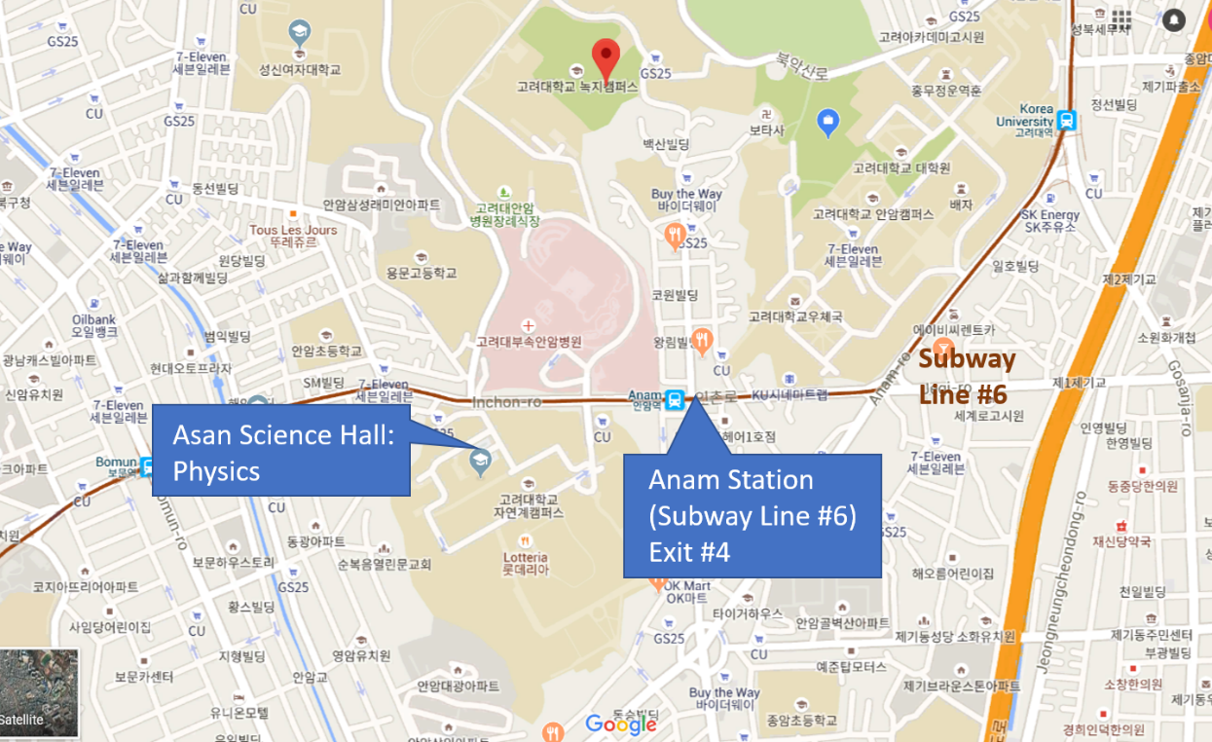
- Nearest hotels
- Best Western (Arirang Hill Dongdaemun) http://www.hotelahill.com/
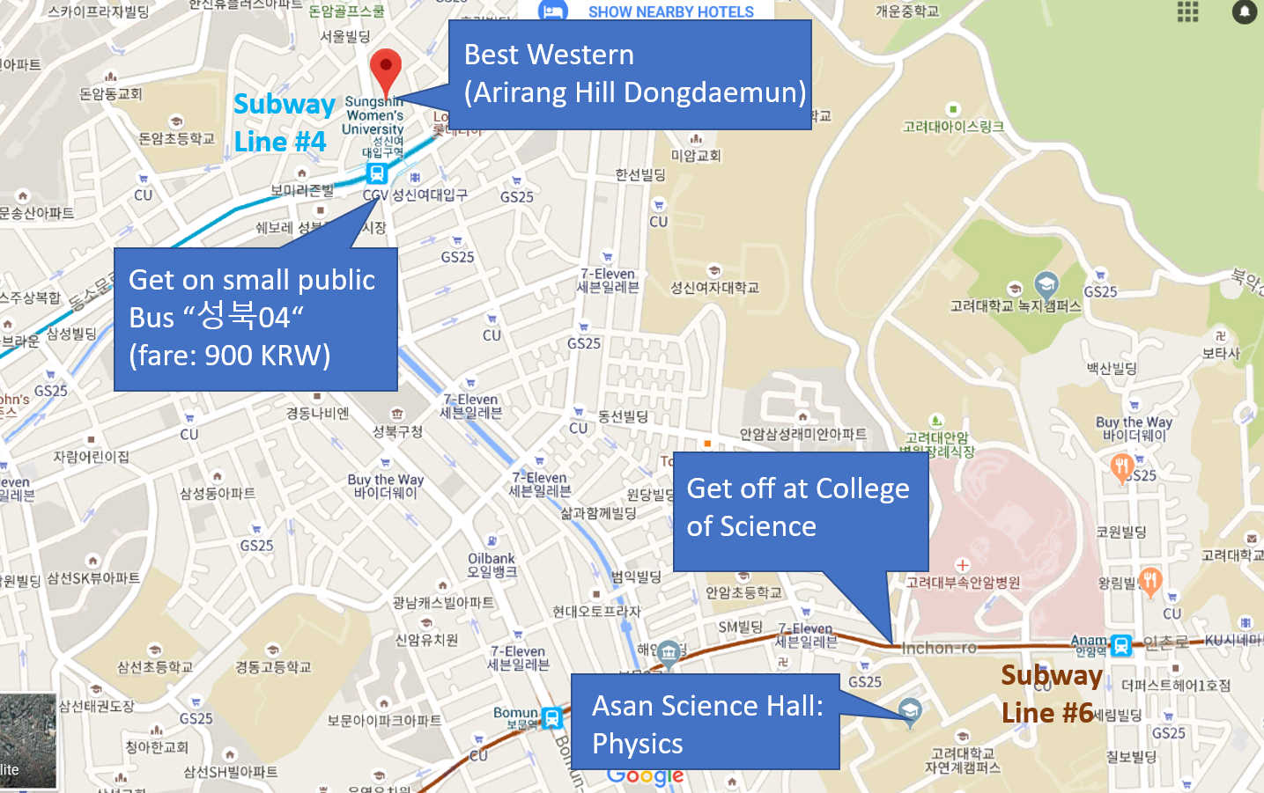
- Ramada Encore (Seoul Dongdaemun) http://www.ramadaencoreseouldongdaemun.com/KR/Main/
