Development of Absolute Epi-thermal and Fast Neutron Flux Intensity Detectors for BNCT

Kazushi Aoki^{†1}, Shingo Tamaki¹, Sachie Kusaka¹, Fuminobu Sato¹, Isao Murata¹
1 Graduate School of Engineering, Osaka University 2-1 Yamada-oka, Suita-si, Osaka-hu 565-0871, Japan
† aoki@qr.see.eng.osaka-u.ac.jp

Abstract
An absolute epi-thermal neutron (0.5 eV ~ 10 keV) flux intensity detector and a fast neutron (10 keV~1 MeV) flux intensity detector were designed and developed for Boron Neutron Capture Therapy (BNCT). After fabricating the detectors, in order to test the performance of the epi-thermal and fast neutron detectors, verification experiments were conducted at KUR, Kyoto University and FNL facility, Tohoku University, respectively. As the result, the epi-thermal neutron flux intensity could be measured with an error of 3.9 % after theoretically correcting the high energy neutron contribution. The fast neutron flux intensity could also be measured accurately, that is, the experimental and calculated values agreed well within the statistical error.

- Introduction
BNCT is a promising cancer therapy which kills tumor cells while suppressing exposure dose to normal tissues. Normally, the neutron field of BNCT, which is produced by a nuclear reactor or an accelerator, has an energy distribution spreading within thermal, epi-thermal and fast neutron regions. Because epi-thermal neutrons are generally used for BNCT, we must measure the epi-thermal neutron flux intensity to evaluate the therapeutic effect and patient’s exposure dose. In addition, we also have to evaluate the exposure dose of the fast neutrons that may be harmful to the human body. However, it is quite difficult to know such intensities directly and accurately, because there is no suitable neutron spectrometer and no activation material covering epi-thermal or fast neutrons separately. The objective of this work is hence to develop new detectors to precisely measure the absolute integral flux intensities of epi-thermal (0.5 eV ~ 10 keV) and fast neutrons (10 keV ~ 1 MeV).

- Design
  - Design of epi-thermal neutron detector
The followings are design requirements for the epi-thermal neutron detector. ① It should have flat sensitivity for epi-thermal neutrons and no sensitivity for thermal neutrons and fast neutrons. ② It should be as small as possible not to distort the neutron field. ③ It should be available in a strong neutron field. Therefore, we decided to employ the foil activation method. To make the sensitivity flat in epi-thermal energy region, we adopted a rectangular shape detector shown in Fig. 1. The epi-thermal neutron detector we develop controls its sensitivity by using Cd and polyethylene (P.E.). An activation foil is positioned at the center and the foil is covered with P.E. neutron moderator surrounded with a Cd sheet to cut thermal neutrons. As for the calculation method, we used MCNP5 as neutron transport calculation tool. The design procedure consists of two processes. One is to fix the activation foil and P.E. thickness to make the sensitivity flat to epi-thermal neutrons. The other is to design the Cd width to cut over 70 % of the sensitivity for 0.1 eV neutrons. The design goal is that fluctuation in the sensitivity to epi-thermal neutrons is to be within 10 %.

Fig. 1 Design calculation model.

As the design result, ⁷¹Ga (n, γ) ⁷²Ga reaction was selected as the activation detector and the shape of the detector was fixed to be a rectangular polyethylene (5.52 cm cubic) covered with a cadmium sheet of 0.0025 cm in thickness. Fig. 2 shows the finally designed detector’s performance. The fluctuation of the production yield of ⁷²Ga for epi-thermal neutron is 8.4 % and the shielding rate of 0.1 eV neutron is 74.6 %. However, this detector is a little sensitive to fast neutrons.

Fig. 2 Sensitivity of epi-thermal neutron detector.

  - Design of fast neutron detector
To clarify the fast neutron contribution, we develop the fast neutron detector. To extract only fast neutrons, the fast neutron detector consists of two sub-detectors, and the fast neutron intensity is estimated by making difference of the two sub-detectors. A fast neutron detector controls the sensitivity by using cadmium, B₄C and polyethylene. The shape of one of the two is a cube covered with polyethylene with a side of 4.4 cm (we call it P.E. type) and the other is a cube covered with B₄C with a side of 4.6 cm (we call it B₄C type) as shown in Fig. 3. For both, GaN foils are covered with Cd sheets.

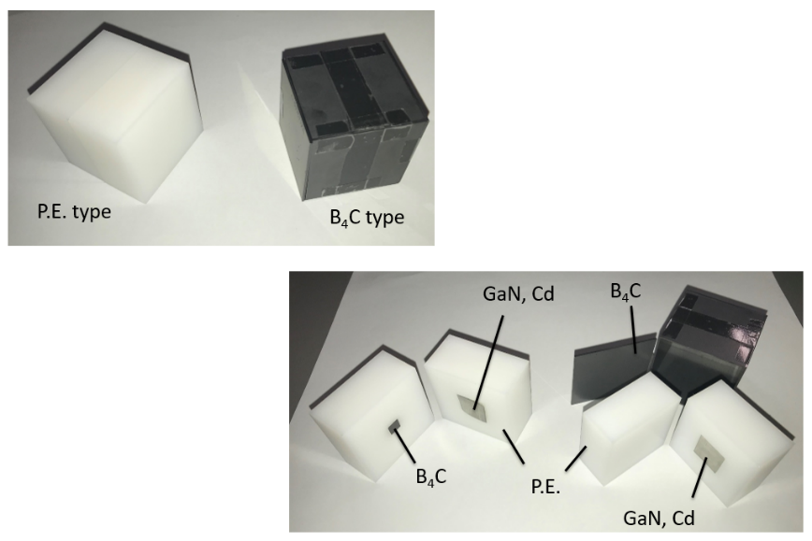
Fig. 3 Prototype fast neutron detectors.

However, in order to reduce the sensitivity to thermal and epi-thermal neutrons, the sensitivity of B₄C type was subtracted from that of P.E. type multiplied by a factor of A = 1.3. Here, the multiplication factor A was calculated so as to make the following equation to have the minimum value. Also, Fig. 4 shows the sensitivity of the fast neutron detector.

$$\begin{aligned}\sum_{E=0.01eV}^{10keV}{{\left(A×Y_{P.E.}\left(E\right)-Y_{B4C}\left(E\right)\right)}^{2}}\#\left(1\right)\end{aligned}$$

where $Y_{P.E.}\left(E\right)$ and $Y_{B4C}\left(E\right)$ are the calculated ⁷²Ga production yields for P.E. type and B₄C type, respectively.

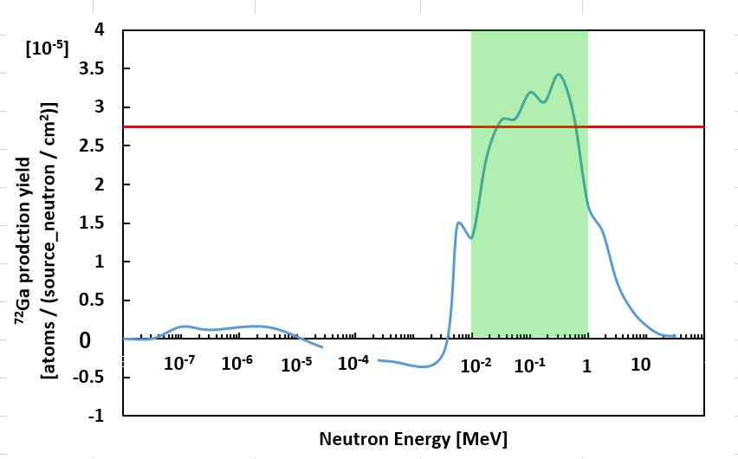
Fig. 4 Sensitivity of fast neutron detector.

- Experiments
  - Validation experiment of epi-thermal neutron detector
In order to test the performance of the epi-thermal neutron detector, a verification experiment was conducted at KUR, Kyoto University. After the experiment, we can deduce the epi-thermal neutron flux intensity by Eq. (2). All we have to do is to measure radioactivity of ⁷²Ga, meaning it is easy and it takes a short time. Fig. 5 shows the experimental set-up in the irradiation field for BNCT at KUR.
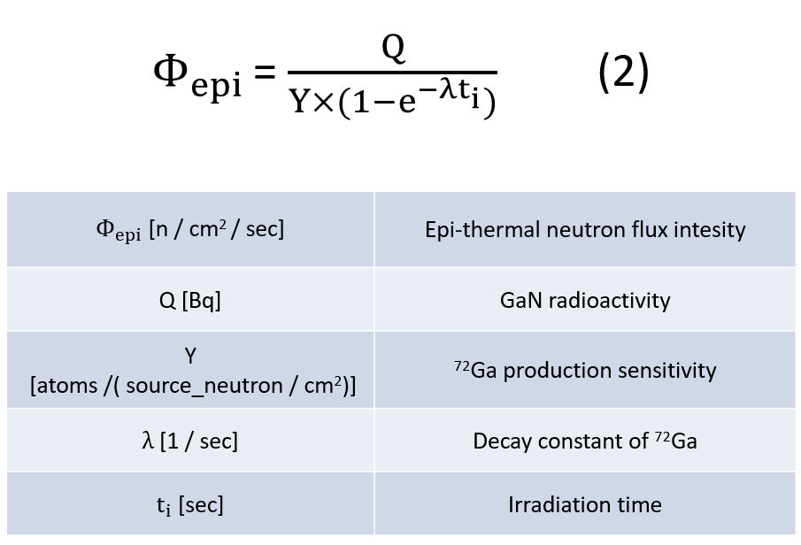
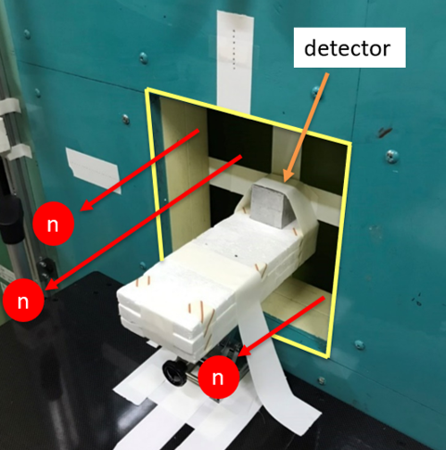
Fig. 5 Irradiation field for BNCT at KUR.

Measurement conditions are shown in Table. 1. The radioactivity immediately after irradiation of GaN was 1.31 kBq. Therefore, the epi-thermal neutron flux intensity is estimated to be 1.76×10⁸ [n/cm²/sec] by using Eq. (2). The nominal value of the epi-thermal neutron (0.5 eV<En<10 keV) flux intensity is given to be 1.62×10⁸ [n/cm²/sec] by KUR. Because this detector is a little sensitive to fast neutrons, a small discrepancy is seen between the experimental value and the nominal value.
To investigate the contribution from fast neutrons, we carried out a correction calculation by MCNP5. As a result, the amount of activation by fast neutrons was estimated to be 50 Bq. Removing the contribution from fast neutron, the radioactivity becomes 1.26 kBq. Then, the epi-thermal neutron flux intensity is finally estimated to be 1.69×10⁸ [n/cm²/sec] by using Eq. (2). It shows an excellent agreement with the given value by ~3.9 %.

Table. 1 Measurement conditions

  - Validity experiment of fast neutron detector
In order to test the performance of the fast neutron detector, a verification experiment was conducted at the FNL facility, Tohoku University. Three types of experiments were performed by changing the applied voltage of proton and the beam current. After the experiment, we can deduce the fast neutron flux intensity by Eq. (3). All we have to do is to measure the radioactivity of the two GaN foils, meaning it is easy and it takes a short time. Fig. 6 shows the experimental set-up in the irradiation field at the FNL facility.
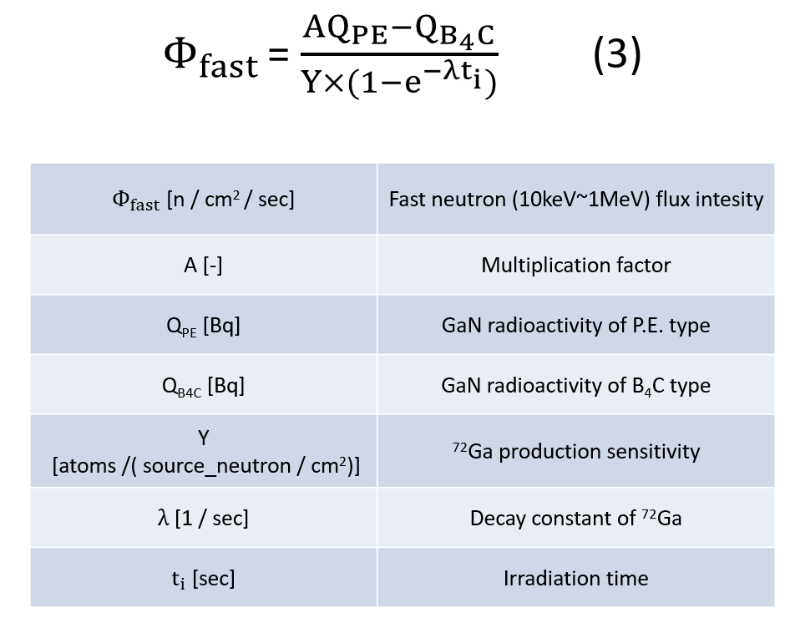
P.E. type
B₄C type
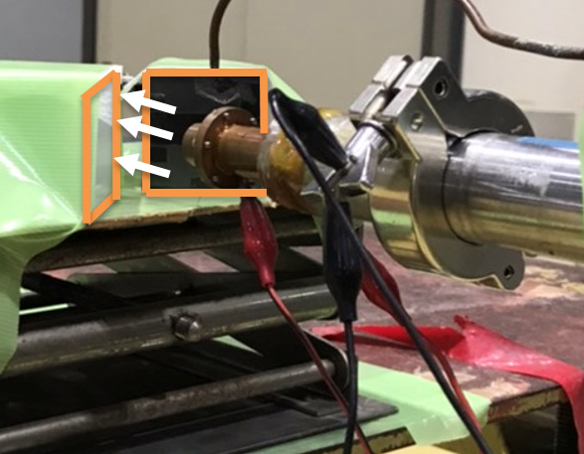
Fig. 6 Irradiation field at the FNL facility.

Fig. 7 shows the experimental fast neutron flux intensities obtained by using the prototype detector compared to the calculated values. From the figure the fast neutron flux intensity could be measured accurately, that is, the experimental and calculated values agree well within the error range. The errors in the experimental and calculated values show slightly large, because errors due to fluctuation of the sensitivity of the prototype detector and 𝛾-ray measurement are included in the error of the experimental value, and simulation and $γ$-ray measurement errors are contained in the error of the calculated value.

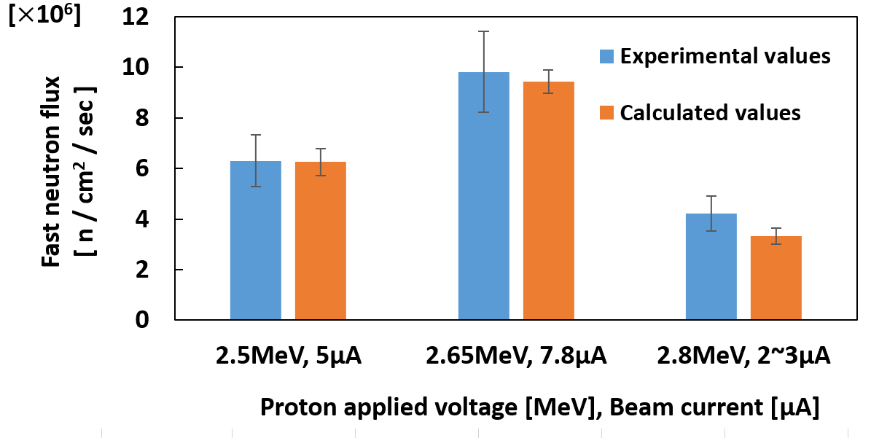
Fig. 7 Estimated fast neutron flux intensity.

- Conclusion
Neutron flux intensity detectors for epi-thermal and fast neutrons were developed and experimentally tested at KUR, Kyoto University and FNL facility, Tohoku University, respectively. As a result, the epi-thermal neutron flux intensity in the neutron field for BNCT in KUR could experimentally be estimated with a good accuracy of 3.9 % error. The fast neutron flux intensity could also experimentally be estimated accurately in FNL of Tohoku University within the error range.
In the future, we will conduct a verification experiment of fast detector at KUR. And thereafter we would like to conduct experiments in a real neutron field of Accelerator-Based Neutron Sources (ABNS) for BNCT.

Acknowledgments
The authors would like to express their sincere gratitude to Drs. Hiroki Tanaka and Yoshinori Sakurai of Institute for Integrated Radiation and Nuclear Science, Kyoto University, who let us use the BNCT irradiation facility at KUR as a cooperative research
, and Dr. Shigeo Matsuyama of Fast Neutron Laboratory, Graduate School of Engineering, Tohoku University, who allowed us to carry out experiments at the FNL facility with his warm support and guidance.

別紙
BNCTのための絶対熱外・高速中性子束強度測定検出器の開発
青木計志、玉置真悟、日下祐江、佐藤文信、村田勲

