Development of Absolute Epi-thermal and Fast Neutron Flux Intensity Detectors for BNCT

Kazushi Aoki^{†1}, Shingo Tamaki¹, Sachie Kusaka¹, Fuminobu Sato¹, Isao Murata¹
1 Graduate School of Engineering, Osaka University, 2-1 Yamada-oka, Suita-si, Osaka-hu 565-0871, Japan
† aoki@qr.see.eng.osaka-u.ac.jp

Abstract
An absolute epi-thermal neutron (0.5 eV ~ 10 keV) flux intensity detector and a fast neutron (10 keV~1 MeV) flux intensity detector were designed and developed for Boron Neutron Capture Therapy (BNCT). After fabricating the detectors, in order to test the performance of the epi-thermal and fast neutron detectors, verification experiments were conducted at KUR [1], Kyoto University and FNL facility [2], Tohoku University, respectively. As the result, the epi-thermal neutron flux intensity could be measured with an error of 3.9 % after theoretically correcting the high energy neutron contribution. The fast neutron flux intensity could also be measured accurately, that is, the experimental and calculated values agreed well within the statistical uncertainty.

- Introduction
BNCT is a promising cancer therapy which kills tumor cells while suppressing exposure dose to normal tissues. Normally, the neutron field of BNCT, which is produced by a nuclear reactor or an accelerator, has an energy distribution spreading within thermal, epi-thermal and fast neutron regions. Because epi-thermal neutrons are generally used for BNCT, we must measure the epi-thermal neutron flux intensity to evaluate the therapeutic effect and patient’s exposure dose. In addition, we also have to evaluate the exposure dose of the fast neutrons that may be harmful to the human body. However, it is quite difficult to know such intensities directly and accurately, because there is no suitable neutron spectrometer and no activation material covering epi-thermal or fast neutrons separately. The objective of this work is hence to develop new detectors to precisely measure the absolute integral flux intensities of epi-thermal (0.5 eV ~ 10 keV) and fast neutrons (10 keV ~ 1 MeV).

- Design
  - Design of epi-thermal neutron detector
The followings are design requirements for the epi-thermal neutron detector. (1) It should have flat sensitivity for epi-thermal neutrons and no sensitivity for thermal neutrons and fast neutrons. (2) It should be as small as possible not to distort the neutron field. (3) It should be available in a strong neutron field. Therefore, we decided to employ the foil activation method. In previous research [3, 4], it was considered to adopt a spherical shape as the detector, but to make the sensitivity flat in epi-thermal energy region, we adopted a rectangular shape detector shown in Fig. 1 [5]. The epi-thermal neutron detector controls its sensitivity by using Cd thermal neutron absorber and polyethylene neutron moderator (P.E.). An activation foil is positioned in the center and the foil is covered with P.E. moderator surrounded with a Cd sheet to cut thermal neutrons. As for the calculation method, we used MCNP5 as neutron transport calculation tool and JENDL-4.0 as evaluated nuclear data library [6]. The design procedure consists of two processes. One is to fix the activation foil and P.E. moderator thickness to make the sensitivity flat to epi-thermal neutrons. The other is to design the Cd thickness to cut over 70 % of the sensitivity for 0.1 eV neutrons. The design goal is that fluctuation in the sensitivity to epi-thermal neutrons is to be within 10 %.

Fig. 1 Design calculation model.

As the design result, ⁷¹Ga (n, $γ$) ⁷²Ga reaction was selected as the activation reaction and the shape of the detector was fixed to be a rectangular polyethylene (5.52 cm³) covered with a cadmium sheet of 0.0025 cm in thickness. Fig. 2 shows the finally designed detector’s sensitivity. The blue line shows the sensitivity of this detector. The green region is the epi-thermal neutron region, and the red line is the average sensitivity in that region. The fluctuation of the production yield of ⁷²Ga for epi-thermal neutron is 8.4 % and the shielding rate of 0.1 eV neutron is 74.6 %. However, this detector is a little sensitive to fast neutrons.

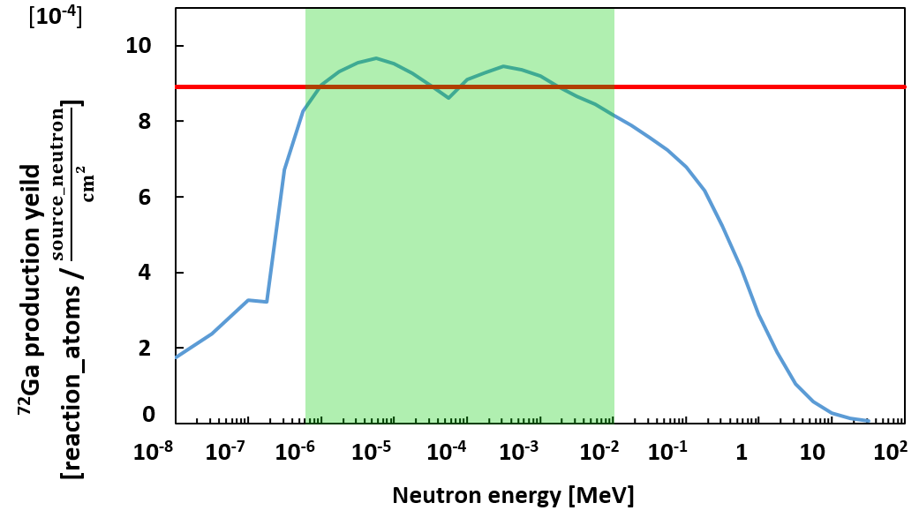
Fig. 2 Sensitivity of epi-thermal neutron detector.
  - Design of fast neutron detector
To clarify the fast neutron contribution, we develop the fast neutron detector. To extract only fast neutrons, the fast neutron detector consists of two sub-detectors, and the fast neutron flux is estimated from the difference in sensitivity between the two sub-detectors. A fast neutron detector controls the sensitivity by using cadmium, B₄C and polyethylene. The shape of one of the two is a cube covered with polyethylene with a side of 4.4 cm (P.E. type) and the other is a cube covered with B₄C with a side of 4.6 cm (B₄C type) as shown in Fig. 3. For both, GaN foils are covered with Cd sheets to eliminate thermal component.

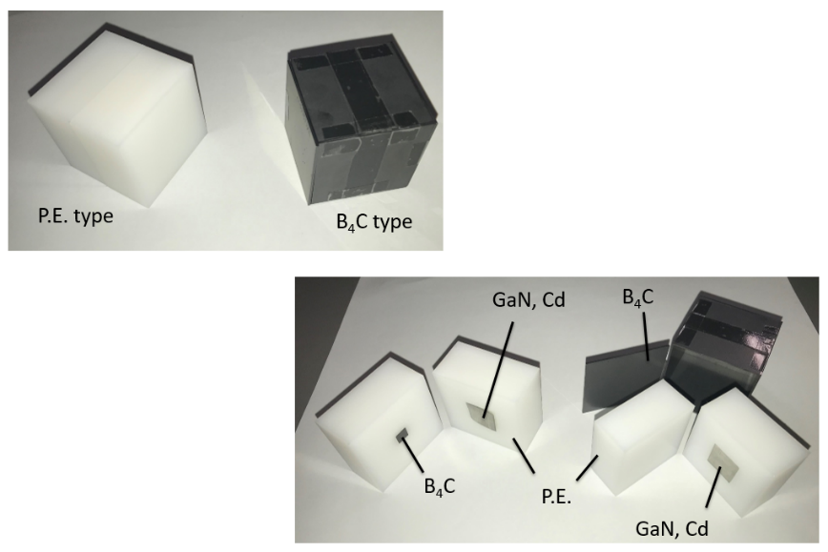
Fig. 3 Prototype fast neutron detectors.

However, in order to reduce the sensitivity to thermal and epi-thermal neutrons, the sensitivity of B₄C type was subtracted from that of P.E. type multiplied by a factor of A = 1.3. Here, the multiplication factor A was calculated so as to make the following equation to have the minimum value. Also, Fig. 4 shows the sensitivity of the fast neutron detector. The blue line shows the sensitivity of this detector. The green region is the fast neutron (10 keV~1 MeV) region, and the red line is the average sensitivity in that region.

$$\begin{aligned}\sum_{E=0.01eV}^{10keV}{{\left(A×Y_{P.E.}\left(E\right)-Y_{B4C}\left(E\right)\right)}^{2}}\#\left(1\right)\end{aligned}$$

where $Y_{P.E.}\left(E\right)$ and $Y_{B4C}\left(E\right)$ are the calculated ⁷²Ga production yields for P.E. type and B₄C type, respectively.

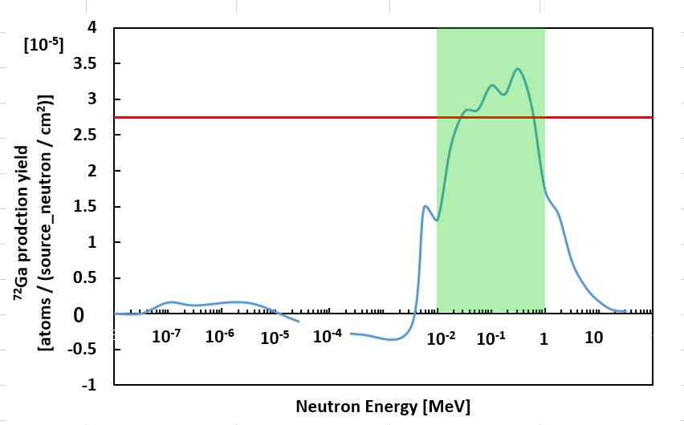
Fig. 4 Sensitivity of fast neutron detector.

- Experiments
  - Validation experiment of epi-thermal neutron detector
In order to test the performance of the epi-thermal neutron detector, a verification experiment was conducted at KUR, Kyoto University. After the experiment, we can deduce the epi-thermal neutron flux intensity $Φ_{epi}$ [n/cm²/sec] by following equation:

$$\begin{aligned}Φ_{epi}=\frac{Q}{Y×\left(1-e^{-λt_{i}}\right)}\#\left(2\right)\end{aligned}$$

where Q [Bq] is radioactivity of ⁷²Ga, Y [$\frac{reaction_atoms}{source_neutron/{cm}^{2}}$] is ⁷²Ga production sensitivity, $λ$ [1/sec] is decay constant of ⁷²Ga and $t_{i}$ [sec] is irradiation time.
In the test, sufficient activity of ⁷²Ga can be induced only a short period irradiation.
Measurement conditions are shown in Table. 1. There are ⁶⁹Ga and ⁷¹Ga in natural Ga. Since this detector uses ⁷¹Ga (n, $γ$) ⁷²Ga reaction, only the radioactivity of ⁷²Ga (834 keV) was measured with the HP-Ge detector. The radioactivity immediately after irradiation of ⁷²Ga was 1.31 kBq [7]. Therefore, the epi-thermal neutron flux intensity is estimated to be 1.75×10⁸ [n/cm²/sec] by using Eq. (2). The nominal value of the epi-thermal neutron (0.5 eV<En<10 keV) flux intensity is given to be 1.52×10⁸ [n/cm²/sec] by KUR. Because this detector is a little sensitive to fast neutrons, a small discrepancy is seen between the experimental value and the nominal value.
To investigate the contribution from fast neutrons, we carried out a correction calculation by MCNP5. As a result, the amount of activation by fast neutrons was estimated to be 50 Bq when simulating with the same system as the experiment. Removing the contribution from fast neutron, the radioactivity becomes 1.26 kBq. Then, the epi-thermal neutron flux intensity is finally estimated to be 1.69×10⁸ [n/cm²/sec] by using Eq. (2). It shows an excellent agreement with the given value by ~10 %.
Table. 1 Measurement conditions
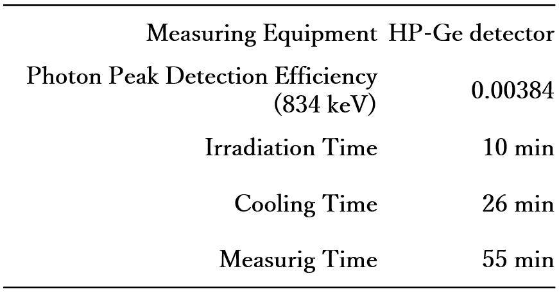

  - Validation experiment of fast neutron detector
In order to test the performance of the fast neutron detector, a verification experiment was conducted at the FNL facility, Tohoku University. Three types of experiments were performed by changing the applied voltage of proton and the beam current. After the experiment, we can deduce the fast neutron flux intensity $Φ_{fast}$ [n/cm²/sec] by following equation:

$$\begin{aligned}Φ_{fast}=\frac{A×Q_{PE}-Q_{B4C}}{Y×\left(1-e^{-λt_{i}}\right)}\#\left(3\right)\end{aligned}$$

where A [-] is multiplication factor, $Q_{PE}$ [Bq] is ⁷²Ga radioactivity of P.E. type, $Q_{B4C}$ [Bq] is ⁷²Ga radioactivity of B₄C type, Y [$\frac{reaction_atoms}{source_neutron/{cm}^{2}}$] is ⁷²Ga production sensitivity, $λ$ [1/sec] is decay constant of ⁷²Ga and $t_{i}$ [sec] is irradiation time.
Table. 2 shows the experimental fast neutron flux intensities obtained by using the prototype detector compared to the calculated values. From this table, the fast neutron flux intensity could be measured accurately.

Table. 2 Estimated fast neutron flux intensity.
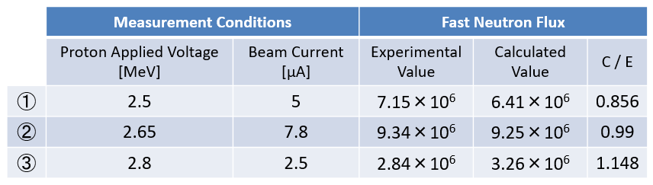

- Conclusion
Neutron flux intensity detectors for epi-thermal and fast neutrons were developed and experimentally tested at KUR, Kyoto University and FNL facility, Tohoku University, respectively. As a result, the epi-thermal neutron flux intensity in the neutron field for BNCT in KUR could experimentally be estimated with a good accuracy of 10 % error. The fast neutron flux intensity could also experimentally be estimated accurately in FNL of Tohoku University.
In the future, we will conduct a verification experiment of fast detector at KUR. And thereafter we would like to conduct experiments in a real neutron field of Accelerator-Based Neutron Sources (ABNS) for BNCT.

Acknowledgments
The authors would like to express their sincere gratitude to Dr. Hiroki Tanaka and Dr. Yoshinori Sakurai of Institute for Integrated Radiation and Nuclear Science, Kyoto University, who let us use the BNCT irradiation facility at KUR as a cooperative research, and Dr. Shigeo Matsuyama of Fast Neutron Laboratory, Graduate School of Engineering, Tohoku University, who allowed us to carry out experiments at the FNL facility with his warm support and guidance.

Reference

[1] | 京都大学複合原子力科学研究所, “京都大学研究用原子炉(KUR),” [オンライン]. Available: https://www.rri.kyoto-u.ac.jp/facilities/kur. [アクセス日: 6 1 2021].
[2] | 東北大学 松山・菊池研究室, “高速中性子実験室 -Fast Neutron Laboratory, Tohoku Univ.-,” [オンライン]. Available: http://web.tohoku.ac.jp/fnl/. [アクセス日: 26 12 2020].
[3] | G. Xingcai, “Design of an epi-thermal neutron flux intensity monitor with GaN wafer for boron,” J. Nucl. Sci. Technol., Vol. 52, No. 4, pp.503–508, 2015.
[4] | G. Xingcai, “Design study of neutron flux intensity monitor between ten and several hundred keV for BNCT,” J. Nucl. Sci. Technol.,Vol. 53, No. 8, pp.1112–1119, 2016.
[5] | Y. Kashiwagi, “Development of epi-thermal neutron beam intensity detector with 71Ga(n,γ)72Ga reaction for boron neutron capture therapy,” Appl. Radiat. Isot. Vol.151, pp.145-149, 2019.
[6] | K. Shibata et. al., "JENDL-4.0: A New Library for Nuclear Science and Engineering," J. Nucl. Technol, vol. 48(1), pp. 1-30, 2011.
[7] | Glenn F. Knoll, "Radiation Detection and Measurement -4th ed.," Wiley, 2010, pp. 767-769.

別紙
BNCTのための絶対熱外・高速中性子束強度測定検出器の開発
青木計志、玉置真悟、日下祐江、佐藤文信、村田勲

