Neutron emission during fission process by dynamical model

R.Yamasaki¹, S.Tanaka^{1,3}, Y.Aritomo^{1,2}, K.Nishio³
¹Graduate School of Science and Engineering, Kindai University
²Faculty of Science and Engineering, Kindai University
Higashi-Osaka, Osaka 577-8502, Japan
³Advanced Science Research Center, Japan Atomic Energy Agency
Tokai, Ibaraki 319-1195, Japan
e-mail: ryoutayamasaki.dia0101@gmail.com

Through joint research by the Japan Atomic Energy Agency and Kindai University, it has revealed that the yield distribution of fission products (fission fragments) changes significantly depending on the neutrons emitted from the compound nucleus. This multichance fission (MCF) effect is particularly important to treat high energy fissions, such as transmutation of long lived minor actinide nucleus by fission using ADS. In this work, we have introduced the neutron evaporation during fission process in the Langevin model and aimed to describe the entire reaction process in a unified manner. The calculated results also reproduced experimental data of the fission-fragment mass distribution.

- Introduction and Background
Since Japan’s energy self-sufficiency rate is as low as 8%, energy diversification is being promoted at each electric power company, and it is expected that the nuclear power generation will continue to play a part of power sources. Long lived minor actinides accumulated in a reactor, is one of the important issues in the nuclear power generation. Therefore, a method of transmuting the long lived minor actinides to short lived minor actinides using Accelerator-driven System (ADS) is considered as a feasible option. ADS applies a proton beam generated by a proton accelerator to a spallation target such as lead and bismuth to generate spallation neutrons. This spallation neutron is used to transmute the long lived minor actinides by fission from highly excited states. From these things, it is important to understand fission from highly excited states.
From the above, through joint research by the Japan Atomic Energy Agency (JAEA) and Kindai University, it has become clear that fission fragment mass distributions (FFMDs) change significantly depending on the neutrons emitted from the compound nucleus. In the so-called multichance fission (MCF) concept, fission takes place after emitting several neutrons. Because the emitted neutrons bring out excitation energy corresponding to neutron binding energy and its kinetic energy, this revives the shell structure of a nucleus responsible for mass-asymmetric fission, thus change the FFMDs. The effect of MCF is particularly important to treat high energy fissions, such as fission process in ADS. Until now, the MCF calculation was performed by combining a fission model calculation (Langevin equation) and a statistical model using a code such as GEF [1,2]. However, this method does not introduce neutron emission during the fission process.
In the conventional method using the GEF code, only neutron emission from the compound nucleus was considered as shown in Fig. 1. Therefore, in this work, we have introduced the neutron evaporation during fission process in the Langevin model as shown in Fig. 2. For this, a change of the potential energy in each neutron evaporation step is treated.
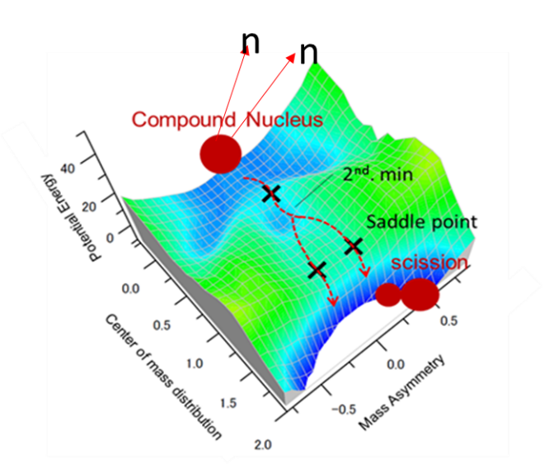
Figure 1 It is a diagram that considers only neutron emission from the compound nucleus, and is a diagram in which a fission path is projected on the potential energy surface.
The saddle points are marked by the symbol “+”.
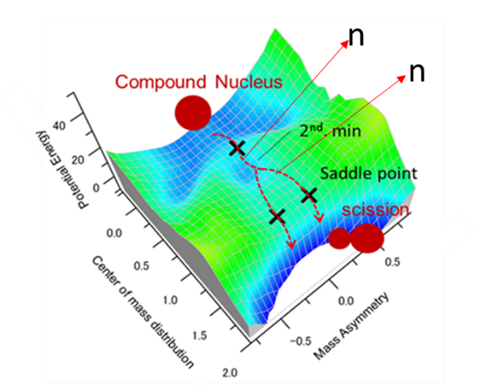
Figure 2 It is a diagram that considers neutron emission in all the processes of fission, and is a diagram in which a fission path is projected on the potential energy surface.
The saddle points are marked by the symbol “+”.
- Theory and Method
A simple neutron decay width $Γ_{n}$ based on detailed balance is adopted, and the Gilbert and Cameron equation is used for the level density $ρ$ [3-5]. The $Γ_{n}$ and $ρ$ are given as
$$Γ_{n}^{J}=\frac{1}{2πρ(E_{CN}^{*},J)}\int_{0}^{E_{f}}{\sum_{l^{'}}{\sum_{s^{'}}{T_{l}\left(ε\right)ρ\left(E_{f}-ε,I^{'}\right)dε }}} (1)$$
$$ρ\left(U^{*},J\right)=\frac{\sqrt{π}}{12a^{1/4}{U^{*}}^{5/4}}\exp\left(2\sqrt{aU^{*}}\right)×\frac{2J+1}{2\sqrt{2π}σ^{3}}exp\left[-\frac{{\left(J+1/2\right)}^{2}}{2σ^{2}}\right] (2)$$
where $E_{CN}^{*}$ and $U^{*}$ are the excitation energy of the compound nucleus and the effective excitation energy of the compound nucleus, respectively. The effective excitation energy of the intermediate nucleus $E_{f}$ can be expressed by $E_{f}=E_{CN}^{*}-B_{n}-E_{k}$($B_{n}$: neutron binding energy, $E_{k}$: emitted neutron kinetic energy). $σ$ is the spin cut-off parameter. The level density parameter a is given as
$$a=a_{0}\left\{1+\frac{E_{shell}}{E^{*}}\left(1-e^{-rE^{*}}\right)\right\}, r=r_{0}A^{-1/3} (3)$$
where $E_{shell}$ is the shell correction energy at temperature of the compound nucleus T=0. In the Langevin model adopted in this study, random number determines the ratio of the Langevin’s time step to the neutron decay width.
In this work, the three-dimensional two-center parametrization was adopted to describe nuclear shape. z is the distance between two potential centers, $δ$ is the deformation of the fragment, $α$ is the mass asymmetry of the two fragments. The advantage of this model is that it can represent both the fusion and the fission with a relatively small number of parameters. The two-center parametrization is described using two harmonic oscillators. $z_{1}$ and $z_{2}$ are the distances from the origin of contact of the harmonic oscillator to the center of each harmonic oscillator. The $z_{0}$, $δ$ and $α$ are given as
$z_{0}=\left|z_{1}\right|+\left|z_{2}\right| (4)$$$δ=\frac{3(a-b)}{2a-b} (5)$$
$$α=\frac{A_{1}-A_{2}}{A_{1}+A_{2}} (6)$$
where $A_{1}$ and $A_{2}$ is the mass numbers of heavy and light fragments, and a and b are the half length of the axes of an ellipse in the $z_{0}$ and ρ directions of the cylindrical coordinate, respectively. In order to shorten the calculation time of the computer when solving the equation of motion, we introduce z as
$$z=\frac{z_{0}}{R_{CN}B} , B=(3+δ)/(3-2δ) (7)$$
where $R_{CN}$ is the radius of the compound nucleus.
In the two-center parametrization, the size of the connecting cross section (neck size) of each fragment is described by the neck parameter $ε$. The $ε$ is givens as
$$ε\left(A_{c}\right)=0.01007A_{c}-1.94 (8)$$
where $A_{c}$ is the mass number of the compound nucleus [6].
In the fission process, the nuclear potential is described by the adiabatic potential $V_{adiab}(q)$. In this case, density of a nucleus is constant. The adiabatic potential is described by the sum of the potential of the liquid drop model and the shell correction energy as
$${ V}_{adiab}\left(q,L,T\right)=V_{LD}\left(q\right)+\frac{ℏ^{2}L(L+1)}{2I(q)}+V_{SH}\left(q,T\right) (9)$$
$${ V}_{LD}\left(q\right)=E_{S}\left(q\right)+E_{C}\left(q\right) \left(10\right)$$
$$V_{SH}\left(q,T\right)=E_{shell}\left(q\right)Φ\left(T\right) (11)$$
$$Φ\left(T\right)=exp\left(-\frac{aT^{2}}{E_{d}}\right) (12)$$
where I(q) is the inertial mass from a rigid body, and $V_{LD}$ is the potential of the liquid drop model. The excitation energy can be expressed by $E^{*}=aT^{2}$(a: level density parameter). $V_{SH}$ is shell correction energy considering temperature dependence. The shell damping energy $E_{d}$ of 20 MeV was used in this work. $E_{S}$ and $E_{C}$ are the surface and coulomb energy, respectively. At the high energy, the shell correction energy becomes extremely small, and the internal structure of the nucleus disappears, resulting in mass symmetric fission.
In this work, the time evolution nuclear shape is described by the Langevin equation. The Langevin equation is given as
$$\frac{dq_{i}}{dt}={\left(m^{-1}\right)}_{ij}p_{j} (13)$$
$$\frac{dp_{i}}{dt}=-\frac{∂V}{∂q_{i}}-\frac{1}{2}\frac{∂}{∂q_{i}}{\left(m^{-1}\right)}_{ik}p_{j}p_{k}-γ_{ij}{\left(m^{-1}\right)}_{jk}p_{k}+g_{ij}R_{j}\left(t\right) (14)$$
where $q_{i}$ = $\left\{z, δ,α\right\}$ and $p_{i}$ is the conjugate momentum of $q_{i}$. $m_{ij}$ and $γ_{ij}$ are the inertial mass and the friction coefficient that depend on the shape of the nucleus, respectively, R is a normalized random variable according to the Gaussian distribution, and $g_{ij}$ is the dimension of the random force.

- Result and Discussion
In this work, FFMDs of ²³⁶⁻²³⁸U, ²³⁸⁻²⁴⁰Np, and ²⁴⁰⁻²⁴²Pu are calculated in the initial excitation energy range of $E^{*}$=15-55 MeV. Fig. 3 shows a comparison between the calculated results and the experimental data measured at JAEA’s tandem accelerator [7-9]. From Fig. 3, the calculation results when neutron emission was taken into consideration in the fission process showed that the mass asymmetric shape of FFMDs was maintained even at high excitation energies. The calculation results can reproduce the experimental data well.
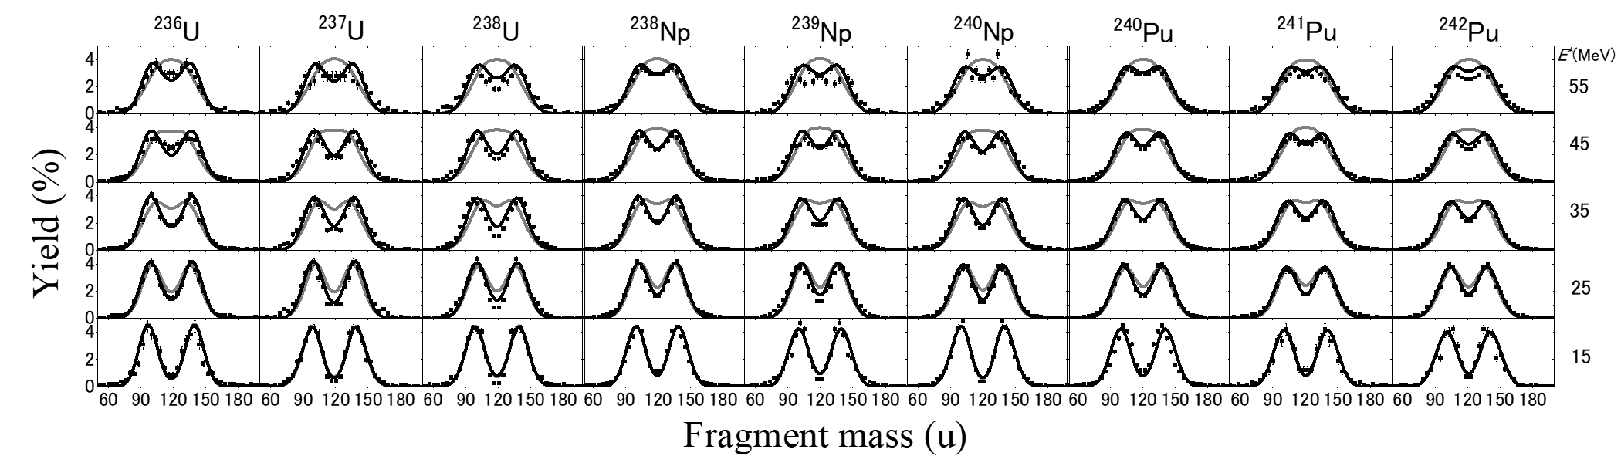
Figure 3 Calculation results of FFMDs without (gray curves) and with (black curves) neutron emission in the fission of ²³⁶⁻²³⁸U, ²³⁸⁻²⁴⁰Np, and ²⁴⁰⁻²⁴²Pu. Dependence on the excitation energy of the initial compound nucleus ($E^{*}$=15-55 MeV, see right hand side of the figure) is shown. The calculation FFMDs are compared with the experimental data (points with error bars) [7-9].

The average number of neutron emissions of ²³⁶⁻²³⁸U, ²³⁸⁻²⁴⁰Np, and ²⁴⁰⁻²⁴²Pu was calculated, and the results are compared to the calculated neutron-emission before fission in the GEF code [1,2]. Looking at the results in Table 1-3, our calculation agrees well with the GEF calculation at high excitation energies. In addition, our calculation does not show any isotope dependence, in contrast to the GEF code, which exhibit a increasing trend of the neutron emission number with the mass of isotope. In addition, at low excitation energies, the average number of neutron emissions calculated by the present Langevin calculation is larger than the GEF result. In the conventional method, only the emission of the excitation energy of 15 MeV from the compound nucleus shape was considered. In the model of this work, the initial value of excitation energy of 15 MeV changes from moment to moment, which may cause a difference. We need to investigate this difference in detail in the future.

Table 1 Average number of neutron emissions Table 2 Average number of neutron emissions
of ²³⁶⁻²³⁸U [1,2] of ²³⁸⁻²⁴⁰Np [1,2]
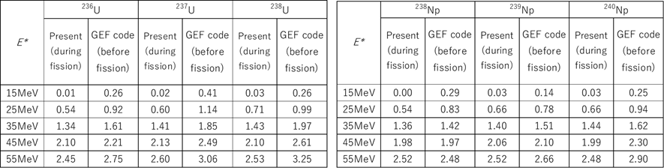

Table 3 Average number of neutron emissions
of ²⁴⁰⁻²⁴²Pu [1,2]
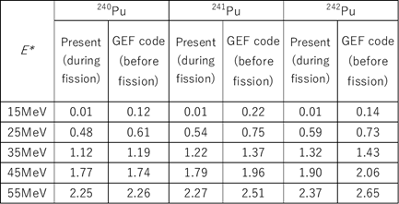

- Summary and Perspectives
We performed the fission calculation including neutron emission during fission process. The calculated results reproduce well the experimental data of FFMDs. It was shown that the method of this work can evaluate neutron emission during fission process. However, the change in the number of neutron emission due to the mass number of the compound nucleus could not be confirmed. We plan to improve the model. We will investigate the shape of the compound nucleus when neutrons are emitted. Also we plan to calculate the fission probability as a function of excitation energy to see if the step-like structure of the reaction cross-section appears at the energy that multi-chance fission emerges.

Reference
[1] S. Tanaka, Y. Aritomo, Y. Miyamoto, et al., Phys. Rev. C 100, 064605 (2019).
[2] K.-H. Schmidt, B. Jurado, C. Amouroux, and C. Schmitt, Nucl. Data Sheets 131, 107 (2016).
[3] A. Gilbert and A.G.W. Cameron, Can.J.Phys. 43, 269 (1965).
[4] V. Weisskopf, Phys. Rev. 52, 295 (1937).
[5] N. Bohr and J.A. Wheeler, Phys. Rev. 56, 426 (1939).
[6] Y. Miyamoto, Y. Aritomo, S. Tanaka, et al., Phys. Rev. C 99, 051601 (2019).
[7] R. Leguillon, K. Nishio, K. Hirose, et al., Phys. Lett. B 761, 125 (2016).
[8] K. Hirose, K. Nishio, S. Tanaka, et al., Phys. Rev. Lett. 119, 222501 (2017).
[9] M. Vermeulen, K. Nishio, K. Hirose, et al., Phys. Rev. C 102, 054610 (2020).

