Measurements of production cross sections of medical radioisotopes via charged-particle-induced reactions

Masayuki AIKAWA^{1*}
¹Faculty of Science, Hokkaido University
N10W8, Kita-ku, Sapporo 060-0810, Japan
*Email: aikawa@sci.hokudai.ac.jp

Production reactions of medical radioisotopes are studied for nuclear medicine. One of such radioisotopes is ¹⁶⁹Yb and its production cross sections of four charged-particle-induced reactions were experimentally determined. Physical yields were derived from the measured cross sections. The comparison of the physical yields indicates that the deuteron-induced reaction on ¹⁶⁹Tm is preferable for the ¹⁶⁹Yb production.

Introduction
Radioisotopes can be used for a variety of applications, e.g., radiotherapy and diagnosis in nuclear medicine. There are basically several reactions on stable nuclei to produce each radioisotope. Investigations of such reactions are necessary to find better reactions with less byproducts and with higher cost-effectiveness. Production cross sections of the radioisotopes are thus important nuclear data. However, there still exist lack of data and data with large errors [1]. It is indispensable to obtain more accurate and reliable data for the application. Recent technical development of accelerators and detectors enables us to reach such data.
¹⁶⁷Yb  17.5 min | ¹⁶⁸Yb  Stable | ¹⁶⁹Yb  32.0 d | ¹⁷⁰Yb  Stable
¹⁶⁶Tm  7.70 h | ¹⁶⁷Tm  9.25 d | ¹⁶⁸Tm  93.1 d | ¹⁶⁹Tm  Stable
¹⁶⁵Er  10.4 h | ¹⁶⁶Er  Stable | ¹⁶⁷Er  Stable | ¹⁶⁸Er  Stable
Figure 1. Nuclear chart around ¹⁶⁹Yb.
We study charged-particle-induced reactions among the possible reactions for the production. The charged-particle-induced reactions have the advantage to be able to produce radioisotopes with atomic numbers different from those of targets. We expect the chemical separation of the products from the targets and obtain the objective radioisotopes with high specific activity.
One of the medical radioisotopes we focused on is ¹⁶⁹Yb (T_{1/2} = 32.018 d, EC = 100%). It is an Auger electron and X-ray emitter and suitable for brachytherapy [2]. To produce ¹⁶⁹Yb, there are several reactions, such as proton-, deuteron- and alpha-induced reactions on thulium and alpha-induced reaction on erbium (Figure 1). We performed experiments to determine cross sections of the four reactions [3–5]. The production cross sections were compared with previous studies and theoretical model calculation in the TENDL library [6]. Physical yields of the products for practical use were also be derived from the measured cross sections. The results are expected to contribute to nuclear medicine.

Method
The experiments were performed at RIKEN, Japan and ATOMKI, Hungary. The well-developed methods, stacked-foil activation technique and high-resolution gamma-ray spectrometry, were adopted. The targets consisted of thin metallic foils for objective and monitor reactions. The stacked targets were irradiated with beams of the charged particles. The beam intensities were measured by a Faraday cup. Gamma rays emitted from the irradiated foils without chemical separation were measured by HPGe detectors. Nuclear data required for deduction of cross sections were retrieved from online databases [7,8].
The cross sections of the monitor reactions were compared with the IAEA recommended values [9] to assess the beam parameters and target thicknesses. According to the comparison of the monitor reactions, only the beam intensities were corrected within the uncertainties. The corrected intensities and measured thicknesses were used to deduce the production cross sections of ¹⁶⁹Yb.
The production cross sections of ¹⁶⁹Yb were derived from measured net counts of the 177.21-keV gamma line (I_{γ} = 22.28%). The more intense gamma lines at 63.12 (I_{γ} = 43.62%) and 197.96 keV (I_{γ} = 35.93%) were unselected because of possible interference with X rays and the 198.25-keV gamma line from the ¹⁶⁸Tm decay (T_{1/2} = 93.1 d).

Result and discussion
We measured cross sections of the four reactions, proton- [3], deuteron- [5] and alpha-induced reactions on ¹⁶⁹Tm and alpha-induced reaction on ^{nat}Er [4]. Physical yields were derived from the measured cross sections and compared with each other. The most appropriate reaction for the ¹⁶⁹Yb production among them was discussed based on the comparison.

¹⁶⁹Tm(p,n)¹⁶⁹Yb reaction
The cross sections of the ¹⁶⁹Tm(p,n)¹⁶⁹Yb reaction were determined as shown in Figure 2 [3]. The result is compared with the previous experimental data [10–12] and the TENDL-2019 values [6]. The peak amplitude and position are consistent with Birattari et al. [10]. The data of Spahn et al. [11] are two times larger than ours. The shape of the TENDL-2019 data is different from the experimental data.

¹⁶⁹Tm(d,2n)¹⁶⁹Yb reaction
The excitation function of the ¹⁶⁹Tm(d,2n)¹⁶⁹Yb reaction was measured [5]. The result is shown in Figure 3 together with the earlier measured experimental data [13,14] and the TENDL-2019 values [6]. The peak position is in good agreement with the previous experimental data and theoretical calculation although our result shows slightly higher than the other experimental data.

¹⁶⁹Tm(α,x)¹⁶⁹Yb reaction
We performed two experiments to measure the cross sections of the ¹⁶⁹Tm(α,x)¹⁶⁹Yb reaction. The cooling times were longer than 86.9 d and 36.5 d for the first and the second experiments. During the cooling times, the co-produced parent nucleus ¹⁶⁹Lu (T_{1/2} = 34.06 h) had entirely decayed to ¹⁶⁹Yb. Therefore, the cumulative cross sections could be obtained. The results are shown in Figure 4 with the TENDL-2019 values [6]. The TENDL-2019 values are very different from our result. There is no previous study found in a literature survey.

^{nat}Er(α,x)¹⁶⁹Yb reaction
The cross sections of the ^{nat}Er(α,x)¹⁶⁹Yb reaction were experimentally determined [4]. The result is shown in Figure 5 in comparison with the previous studies [15–18] and the TENDL-2019 values [6]. Both data of Király et al. [17] and TENDL-2019 have nearly the same peak position as ours at around 35 MeV while the amplitudes are different. The other experimental data differ significantly from our results in both the shape and amplitude.

Physical yield of ¹⁶⁹Yb
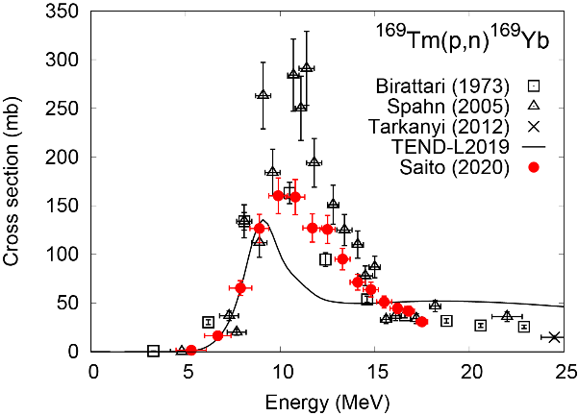 |  | 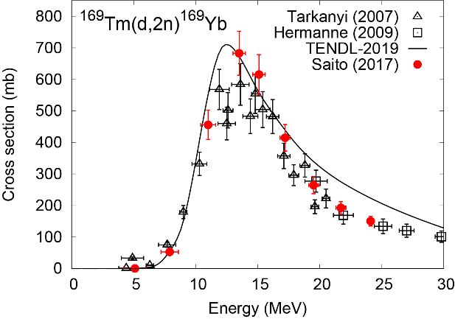
Figure 2. Excitation function of the ¹⁶⁹Tm(p,n)¹⁶⁹Yb reaction with the previous data [13,14] and the TENDL-2019 values [6]. |  | Figure 3. Excitation function of the ¹⁶⁹Tm(d,2n)¹⁶⁹Yb reaction with the previous data [13,14] and the TENDL-2019 values [6].
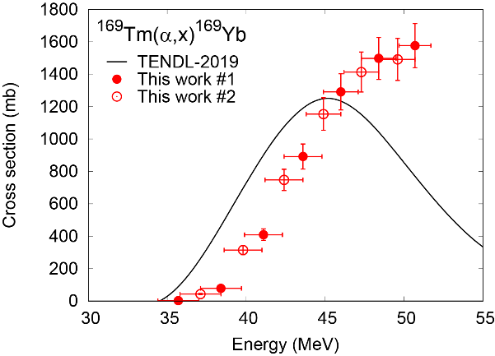 |  | 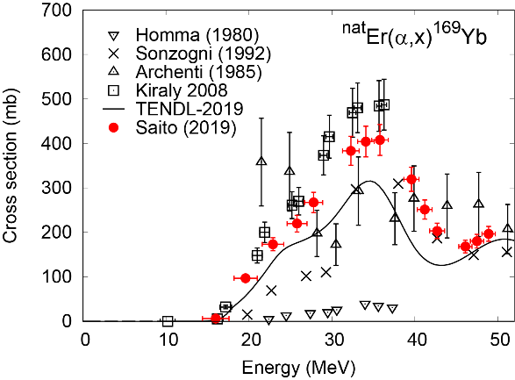
Figure 4. Excitation function of the ¹⁶⁹Tm(α,x)¹⁶⁹Yb reaction with the TENDL-2019 values [6]. |  | Figure 5. Excitation function of the ^{nat}Er(α,x)¹⁶⁹Yb reaction with the previous data [15–18] and the TENDL-2019 values [6].
Physical yields of ¹⁶⁹Yb in the proton-, deuteron-, alpha-induced reactions on ¹⁶⁹Tm and alpha-induced reaction on ^{nat}Er were derived from the measured cross sections. The results are shown in Figure 6 and found that the deuteron-induced reaction on ¹⁶⁹Tm is preferable to produce ¹⁶⁹Yb. We can obtain ¹⁶⁹Yb without any radioactive impurities using chemical separation because co-produced ¹⁶⁸Yb and ¹⁷⁰Yb are stable.

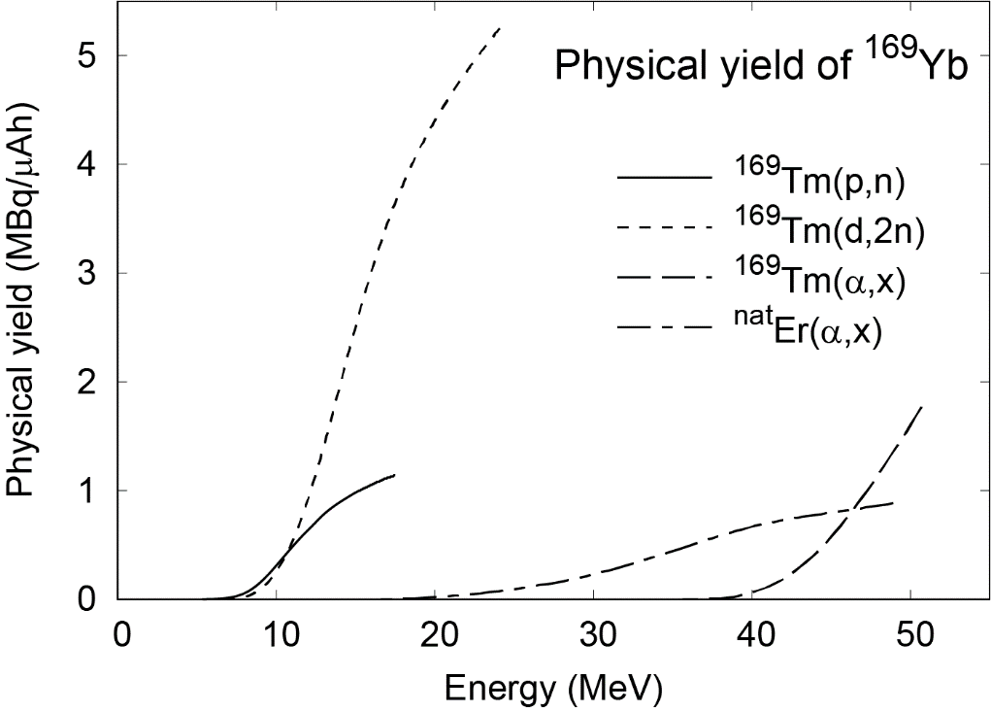
Figure 6. Physical yields derived from the measured cross sections.

Conclusion
The production reactions of the medical radioisotope ¹⁶⁹Yb were investigated. The cross sections of four charged-particle-induced reactions were measured in RIKEN, Japan and ATOMKI, Hungary. Physical yields were determined from the measured cross sections and compared with each other. According to the comparison, the deuteron-induced reaction on ¹⁶⁹Tm is the most appropriate for the production.

References
- Capote R, Nichols AL, Nortier FM, et al. IAEA coordinated research project on nuclear data for charged-particle monitor reactions and medical isotope production. EPJ Web Conf. 2017;146:08007.
- Leonard KL, DiPetrillo TA, Munro JJ, et al. A novel ytterbium-169 brachytherapy source and delivery system for use in conjunction with minimally invasive wedge resection of early-stage lung cancer. Brachytherapy. 2011;10:163–169.
- Saito M, Aikawa M, Murata T, et al. Production cross sections of ¹⁶⁹Yb by the proton-induced reaction on ¹⁶⁹Tm. Nucl Instruments Methods Phys Res Sect B. 2020;471:13–16.
- Saito M, Aikawa M, Sakaguchi M, et al. Production cross sections of ytterbium and thulium radioisotopes in alpha-induced nuclear reactions on natural erbium. Appl Radiat Isot. 2019;154:108874.
- Saito M, Aikawa M, Komori Y, et al. Production cross sections of ¹⁶⁹Yb and Tm isotopes in deuteron-induced reactions on ¹⁶⁹Tm. Appl Radiat Isot. 2017;125:23–26.
- Koning AJ, Rochman D, Sublet J, et al. TENDL: Complete Nuclear Data Library for Innovative Nuclear Science and Technology. Nucl Data Sheets. 2019;155:1–55.
- International Atomic Energy Agency. LiveChart of Nuclides [Internet]. 2009 [cited 2021 Jan 10]. Available from: https://www-nds.iaea.org/livechart/.
- National Nuclear Data Center. Nuclear structure and decay data on-line library, Nudat 2.8 [Internet]. 2019 [cited 2021 Jan 10]. Available from: http://www.nndc.bnl.gov/nudat2/.
- Hermanne A, Ignatyuk A V., Capote R, et al. Reference Cross Sections for Charged-particle Monitor Reactions. Nucl Data Sheets. 2018;148:338–382.
- Birattari C, Gadioli E, Gadioli Erba E, et al. PRE-EQUILIBRIUM PROCESSES IN (p,n) REACTIONS. Nucl Phys A. 1973;201:579–592.
- Spahn I, Takács S, Shubin YN, et al. Cross-section measurement of the ¹⁶⁹Tm(p,n) reaction for the production of the therapeutic radionuclide ¹⁶⁹Yb and comparison with its reactor-based generation. Appl Radiat Isot. 2005;63:235–239.
- Tárkányi F, Hermanne A, Takács S, et al. Activation cross-sections of proton induced nuclear reactions on thulium in the 20-45MeV energy range. Appl Radiat Isot. 2012;70:309–314.
- Hermanne A, Tárkányi F, Takács S, et al. Excitation functions for production of medically relevant radioisotopes in deuteron irradiations of Pr and Tm targets. Nucl Instruments Methods Phys Res Sect B. 2009;267:727–736.
- Tárkányi F, Hermanne A, Takács S, et al. Activation cross sections of the ¹⁶⁹Tm(d,2n) reaction for production of the therapeutic radionuclide ¹⁶⁹Yb. Appl Radiat Isot. 2007;65:663–668.
- Homma Y, Sugitani Y, Matsui Y, et al. Cyclotron production of ¹⁶⁷Tm from natural erbium and natural holmium. Appl Radiat Isot. 1980;31:505–508.
- Sonzogni AA, Romo ASMA, Ozafran MJ, et al. Alpha-induced reactions on natural erbium. J Radioanal Nucl Chem Lett. 1992;165:295–303.
- Király B, Tárkányi F, Takács S, et al. Excitation functions of alpha-induced nuclear reactions on natural erbium. Nucl Instruments Methods Phys Res Sect B. 2008;266:549–554.
- Archenti A, Wasilevsky C, De La Vega Vedoya M, et al. (α,xn) Reactions on Natural Erbium. Radiochim Acta. 1985;38:65–68.

Acknowledgements
This work was carried out at RI Beam Factory operated by RIKEN Nishina Center and CNS, University of Tokyo, Japan. A part of this work was supported by JSPS KAKENHI Grant Number 17K07004.

