Comparison of photon spectra emitted from fuel debris using different decay data libraries

Taichi MATSUMURA*, Keisuke OKUMURA, and Manabu FUJITA

Collaborative Laboratories for Advanced Decommissioning Science (CLADS), Japan Atomic Energy Agency (JAEA), 790-1 Ootsuka, Motooka, Tomioka-machi, Futaba-gun, Fukushima, 979-1151, Japan

**Abstract**

We compared the photon spectra calculated for the fuel debris using three recent decay data libraries: JENDL/DDF-2015, the decay sub-libraries of ENDF/B-VIII.0 and JEFF-3.3. We found that X-ray data for 137mBa, γ-ray data for 241Am at 60 keV, and γ-ray data for 106Rh in the energy region 3.0–3.4 MeV are missing in JENDL/DDF-2015. In addition, we found that the 33 radioactive daughter nuclides are not defined in the decay chains in JENDL/DDF-2015.

**1. Introduction**

Evaluated nuclear data has been used for the development of new sensors, non-destructive assay technologies, and the optimization of radiation shielding in connection with the decommissioning of the Fukushima Daiichi Nuclear Power Station (1F). We need reliably evaluated nuclear data in order to determine the radiation characteristics of the fuel debris. However, different collections of evaluated nuclear data give different results, and it has been difficult to clarify the causes of the differences. This is because different decay calculation codes deal with so many different nuclides and their decay data in different numerical solutions and different conditions. To overcome this problem, we have developed a reliable new code for calculating the radiation decay and radioactive-source spectra, and it can accurately treat large amounts of nuclides and all the decay modes in the decay data library.

In this study, we focused on the photon spectrum of the fuel debris, and we investigated the causes of the differences in the photon spectra calculated by our new code using three evaluated decay data libraries: JENDL/DDF-2015 [1], the decay sub-libraries of ENDF/B-VIII.0 [2] and JEFF-3.3 [3]. We expect the results to be reflected in the next JENDL release (e.g., JENDL-5) and to be utilized as reliable nuclear data for Fukushima 1F R&D.

**2. Method**

In this study, we calculated the X-rays and γ-rays emitted from the Fukushima fuel debris using JENDL/DDF-2015, ENDF/B-VIII.0, and JEFF-3.3 as follows. As shown in Fig.1, in the first step, we performed a three-dimensional fuel-inventory calculation, taking into account the burnup and void distributions in the core of unit-2. We also performed an activation calculation for the structural materials in the core. Then we mixed all the nuclides so-obtained together to imitate the fuel debris. In the second step, we calculated the amounts of all the nuclides remaining after the 10 years that have passed since the 1F accident. We used the Chebyshev rational-approximation method (CRAM), in which the complete nuclear-transmutation matrix from each decay library can be considered. Finally, we evaluated the photon spectrum using the photon-emission data from each decay data library. Since the photon spectrum of the fuel debris consists of many line spectra with different energies, for easy comparison we converted the photon spectrum into the 18-energy-group structure (Table 1) used in the ORIGEN-S code [4].

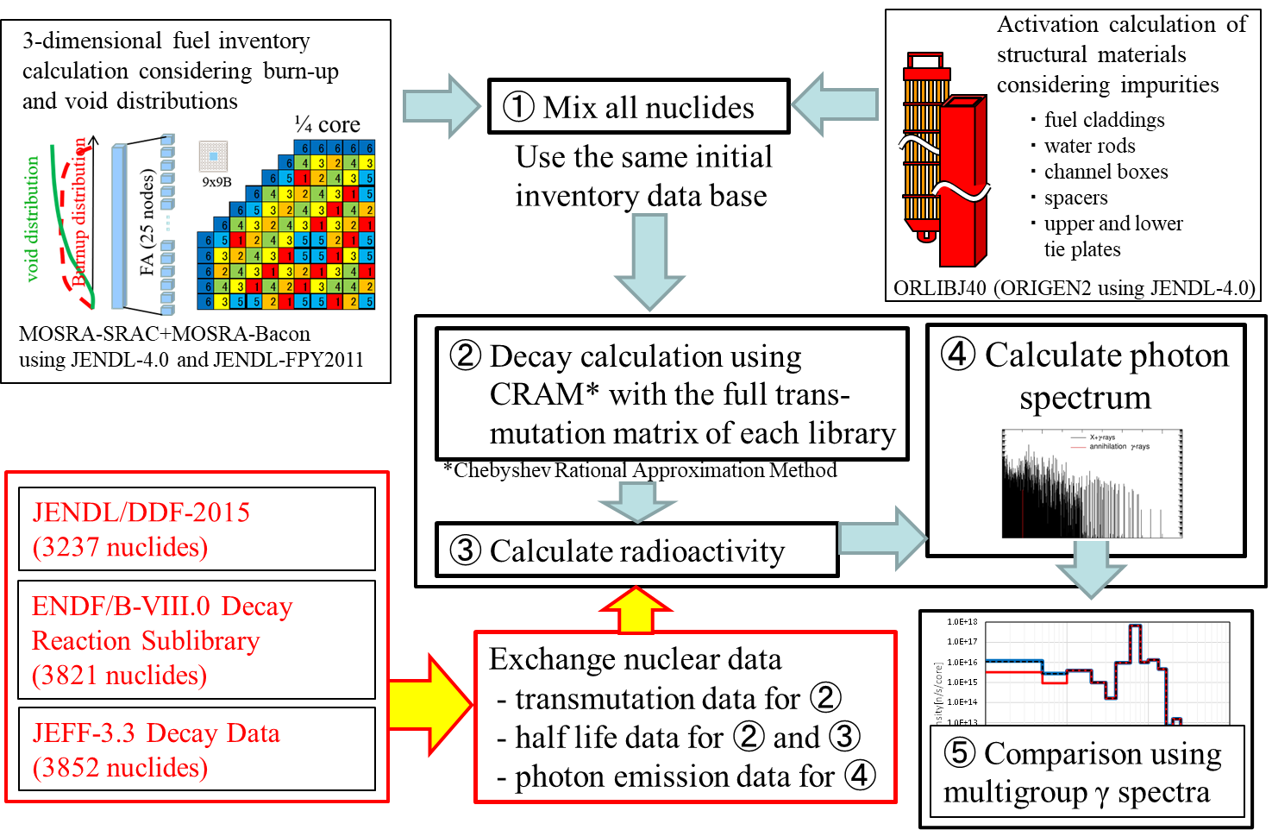

Figure 1 Method used to calculate the photon spectrum.

Table 1 18-energy-group structure.

|  |  |  |  |
| --- | --- | --- | --- |
|  | Group Energy (MeV) | | |
| Group | Lower boundary | Upper boundary | Average |
| 1 | 8.00E+00 | 1.00E+01 | 9.00E+00 |
| 2 | 6.50E+00 | 8.00E+00 | 7.25E+00 |
| 3 | 5.00E+00 | 6.50E+00 | 5.75E+00 |
| 4 | 4.00E+00 | 5.00E+00 | 4.50E+00 |
| 5 | 3.00E+00 | 4.00E+00 | 3.50E+00 |
| 6 | 2.50E+00 | 3.00E+00 | 2.75E+00 |
| 7 | 2.00E+00 | 2.50E+00 | 2.25E+00 |
| 8 | 1.66E+00 | 2.00E+00 | 1.83E+00 |
| 9 | 1.33E+00 | 1.66E+00 | 1.50E+00 |
| 10 | 1.00E+00 | 1.33E+00 | 1.17E+00 |
| 11 | 8.00E-01 | 1.00E+00 | 9.00E-01 |
| 12 | 6.00E-01 | 8.00E-01 | 7.00E-01 |
| 13 | 4.00E-01 | 6.00E-01 | 5.00E-01 |
| 14 | 3.00E-01 | 4.00E-01 | 3.50E-01 |
| 15 | 2.00E-01 | 3.00E-01 | 2.50E-01 |
| 16 | 1.00E-01 | 2.00E-01 | 1.50E-01 |
| 17 | 5.00E-02 | 1.00E-01 | 7.50E-02 |
| 18 | 1.00E-02 | 5.00E-02 | 3.00E-02 |

**3. Results**

We compared the 18-energy-group photon spectra obtained by using decay data from JENDL/DDF-2015, ENDF/B-VIII.0, and JEFF-3.3. The results are compared in Fig. 2. The ratio of JENDL/DDF-2015 to ENDF/B-VIII.0 is 93% over the total energy range, and the actual shape of the energy spectrum is important for purposes like the development of detectors or radiation shielding. In the energy regions where there are differences, we confirmed the differences in the photon intensities of the decay data library by each nuclide. We extracted nuclides that do not emit X-rays or γ-rays or those for which the intensity is smaller compared with other libraries, especially those that have a strong influence on photon intensities in the 18-energy-group structure.



Figure 2 The different photon spectra obtained using recent decay data libraries for the Fukushima fuel debris 10 years after the 1F accident (using core-averaged values for unit-2 in 2021, for which there was no volatile fission-product release).

In the energy region from 10–50 keV, X-rays from 137mBa are not defined in JENDL/DDF-2015 and are therefore underestimated. Figure 3 shows the photon intensities of the 137mBa line spectra evaluated from JENDL/DDF-2015 and ENDF/B-VIII.0. In JENDL/DDF-2015, the X-ray intensities are defined for most of nuclides, but not for 137mBa. Although the half-life of 137mBa is short (about 2.6 min.), the X-rays from 137mBa are not negligible because this (nuclear) state is produced by the β- decay of a large amount of 137Cs, which has a half-life of about 30 years.

 

Figure 3 Photon spectra of 137mBa using ENDF/B-VIII.0 (left) and JENDL/DDF-2015 (right)

In the energy region from 50–100 keV, JENDL/DDF-2015 underestimates the γ-rays from 241Am because they are not defined in this library. Figure 4 shows the 241Am line spectra from JENDL/DDF-2015 and ENDF/B-VIII.0. The famous γ-ray line at 59.5 keV is defined in ENDF/B-VIII.0, but not in JENDL/DDF-2015. In addition, photons with strong intensities are observed at lower energies only in ENDF/B-VIII.0.

 

Figure 4 Photon spectra of 241Am using ENDF/B-VIII.0 (left) and JENDL/DDF-2015 (right).

In the energy region from 3–3.4 MeV, JENDL/DDF-2015 underestimates the γ-rays from 106Rh, because the γ-ray production is smaller in this energy region than is that obtained from ENDF/B-VIII.0. Figure 5 shows the line spectra of photons above 1 MeV for 106Rh from JENDL/DDF-2015 and from ENDF/B-VIII.0. While ENDF/B-VIII.0 defines multiple photon intensities above 3 MeV, JENDL/DDF-2015 defines only one photon intensity above 3 MeV. Although the photons from 106Rh may be negligible in the fuel debris considered in this study, it is usually important as a photon source from the β- decay of 106Ru, which has a half-life of 1.0 y, and the 106Rh is in radiation equilibrium.

 

Figure 5 Photon spectra of 106Rh using ENDF/B-VIII.0 (left) and JENDL/DDF-2015 (right).

By comparing the 10-year-elapsed photon spectra obtained using JENDL/DDF-2015, ENDF/B-VIII.0, and JEFF-3.3, we conclude that 137mBa, 241Am, and 106Rh are the main causes of the differences in the overall photon spectrum from JENDL/DDF-2015. To confirm this, we replaced the decay data for these three nuclides in JENDL/DDF-2015 with those from ENDF/B-VIII.0. The 18-energy-group spectrum obtained with the modified JENDL/DDF-2015 then agreed with those obtained using ENDF/B-VIII and JEFF-3.3, as shown in Fig. 6. The differences in the energy-integrated photon intensities became smaller, and the ratio of the modified JENDL/DDF-2015 to ENDF/B-VIII.0 improved to 99%.



Figure 6 Modified photon spectrum.

Unlisted daughter nuclides also exist in JENDL/DDF-2015. Table 2 shows the nuclides for which the parent nuclide is defined in JENDL/DDF-2015 but the daughter nuclide is not defined, together with their main production paths. Therefore, the decay chain breaks off. For example, the α-decay of 239Pu (T1/2＝2.4×104 y) is expressed as 239Pu → 235mU + α, but 235mU does not exist in this library. As a result, the amount of 235U and its daughter nuclides will be underestimated by about 20% after a long decay time such as 1000 years, because the immediate decays from 235mU to 235U are not counted. We found 33 nuclides for which the daughter nuclides are not defined.

Table 2 The unlisted daughter nuclides.



**4. Conclusion**

We need reliable nuclear data to evaluate the radiation characteristics of fuel debris appropriately for the purpose of developing new sensors and non-destructive assay technologies and for optimizing radiation shielding for use in decommissioning. This research revealed the following main points. We found that X-ray data for 137mBa, γ-ray data for 241Am at 60 keV, and γ-ray data for 106Rh in the range 3.0–3.4 MeV are missing from JENDL/DDF-2015. In addition, in JENDL/DDF-2015 we found that the 33 daughter nuclides are not defined. We anticipate that these problems will be corrected in the next JENDL release.

**5. References**

[1] J. Katakura and F. Minato “JENDL Decay Data File 2015, “JAEA-Data/Code 2015-030 (Mar 2016).

[2] D.A. Brown, et al., ENDF/B-VIII.0: the 8th major release of the nuclear reaction data library with CIELO-project cross sections, new standards and thermal scattering data. Nucl. Data Sheets, 148. 1-42 (2018).

[3] OECD/NEA Data Bank, JEFF-3.3, https://www.oecd-nea.org/dbdata/jeff/jeff33/index.html (2017).

[4] I. C. Gauld, O. W. Hermann, R. M. Westfall, Origen-S: Scale system module to calculate fuel depletion, Actinide transmutation, fission product buildup and decay, and associated radiation source terms, Vol. II (2009).