Comparison of double-differential cross sections between JENDL/PD-2016.1 and experimental data for photo-neutron production of medium-heavy nuclei at 16.6 MeV
*T.K.Tuyet¹, Y.Sakaki², T.Sanami^{1,2}, H.Yamazaki^{1,2}, T.Itoga³, A.Takeuchi¹, S.Miyamoto⁴ and Y.Asano²
¹SOKENDAI, Shonan Village, Hayama, Kanagawa 240-0193 Japan
²KEK, 1-1 Oho, Tsukuba-shi, Ibaraki-ken 305-0801 Japan
³JASRI, 1-1-2, Kouto, Kamigori-cho, Ako-gun, Hyogo 678-1205, Japan
⁴University of Hyogo, 1-1-2, Kouto, Kamigori-cho, Ako-gun, Hyogo 678-1205, Japan
Email: tuyet@post.kek.jp
Abstract: Understanding the photoneutrons' production from high-energy photons plays an important role in accelerators' shielding design. We measured the double differential cross sections (DDX) for the (γ,xn) with 16.6 MeV polarized photons on Pb, Au, Sn, Cu, Fe, and Ti targets and observed the low-energy and high-energy components on the neutron energy spectra. In this work, we present the first comparison between the DDXs from JENDL/PD-2016.1, used in Monte Carlo simulation tools to evaluate dose rate. There is a disagreement between the JENDL/PD-2016.1 and experimental data. The photoneutron's low energy component agrees with the JENDL/PD-2016.1, while the high-energy component does not.

- Introduction
In an electron accelerator, high-energy photons can be produced as bremsstrahlung radiations. These photons can interact with surrounding accelerator components, and via the photonuclear reaction, produces secondary particles including neutrons are produced. The double differential cross-section (DDX) of the photoneutron is an essential quantity for radiation shielding and shielding calculation of the electron accelerator design.
Until now, there are researches about photo-neutrons production in photonuclear reaction [1-4]. In the previous study of our research group [1], photoneutrons' energy spectra produced by the reaction of 16.6 MeV polarized photons on the Pb, Au, Sn, Cu, Fe, and Ti targets were measured at various angles. The low-energy and high-energy components were identified in the energy spectra [1]. The angular distribution of the low-energy component showed isotropic, while the high-energy component showed a dependence on the interaction angle between photon polarization and neutron emission [1].
The evaluated nuclear data library is used in simulation tools (such as PHITS, which is mentioned in section 3) for shielding calculation and particle transportation. Comparison between the experimental data and the evaluated data on DDXs of medium to heavy targets provides new information on photo-neutron energy and angular distribution in addition to show contributions from evaporation and pre-equilibrium processes separately.
- Experiment
The experiment was performed at NewSUBARU-BL01, Hyogo, Japan. The details of our experimental setup were mentioned in Ref. [1]. Figure 1 indicates a detector system and setup of photoneutron measurement.

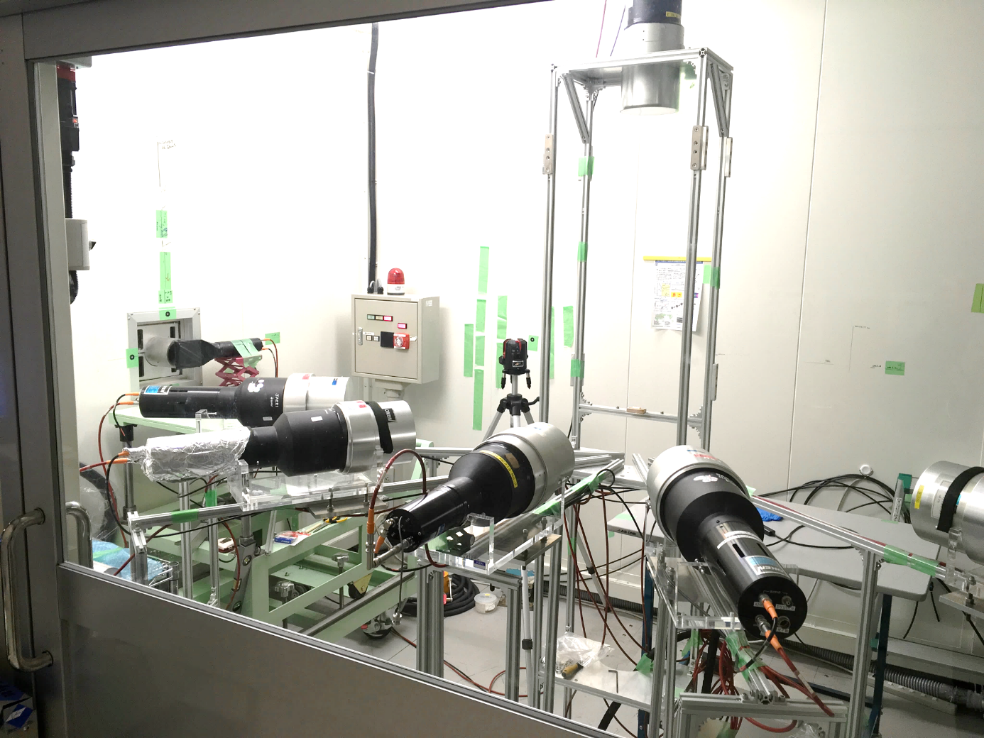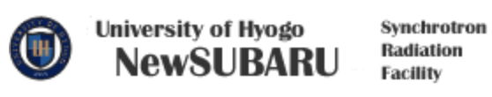
Figure 1. The experimental setup of the photo-neutron measurement
LCS γ-ray 16.6 MeV
neutron
target
Plastic
In this measurement, we determined the photoneutron production per incident LCS photon. We placed a plastic scintillator, with 0.5 cm thickness and 10 cm2 surface area, at 179.7 cm upstream from the target to estimate the number of incidents LCS photons. The cylindrical-shaped targets of Pb, Au, Sn, Cu, Fe, and Ti, with 1 cm diameter and 1-4 cm thicknesses, were prepared in this experiment. The LCS photons interact with the prepared targets and generate neutrons. We placed six 12.7 cm^{φ}×12.7 cm^{L} cylindrical detector filled with NE213 organic liquid scintillator at different angles 30⁰, 60⁰, 90⁰, 120⁰, 150⁰ (horizontally), and 90⁰ (vertically), with respect to the photon beam axis. The distances from the target center to the detectors ranged from 60 to 90 cm. As the neutron detector was sensitive to both photoneutrons and background gamma radiations, a pulse shape discrimination (PSD) method was employed. The time-of-flight (TOF) technique was employed to measure the neutron energy. A VME-based data acquisition (DAQ) system was set up to collect the tail and full charges of NE213’s signals by using a QDC module and measure the time difference between the LCS photon and NE213 detector by using a TDC module. The energy deposited in the plastic scintillator was also measured by our DAQ. The neutron was distinguished from gamma events by a two-dimensional plot of time-of-flight vs ratio of light outputs from slow and total gates (Slow/Total). Figure 2 displays neutron-gamma events separation. Figure 3 indicates neutron-gamma time-of-flight spectra after neutron-gamma events separation. An energy threshold of 0.25 MeVee employed in our data was determined by energy calibration using gamma radiations of ¹³⁷Cs, ²²Na, and ⁶⁰Co.
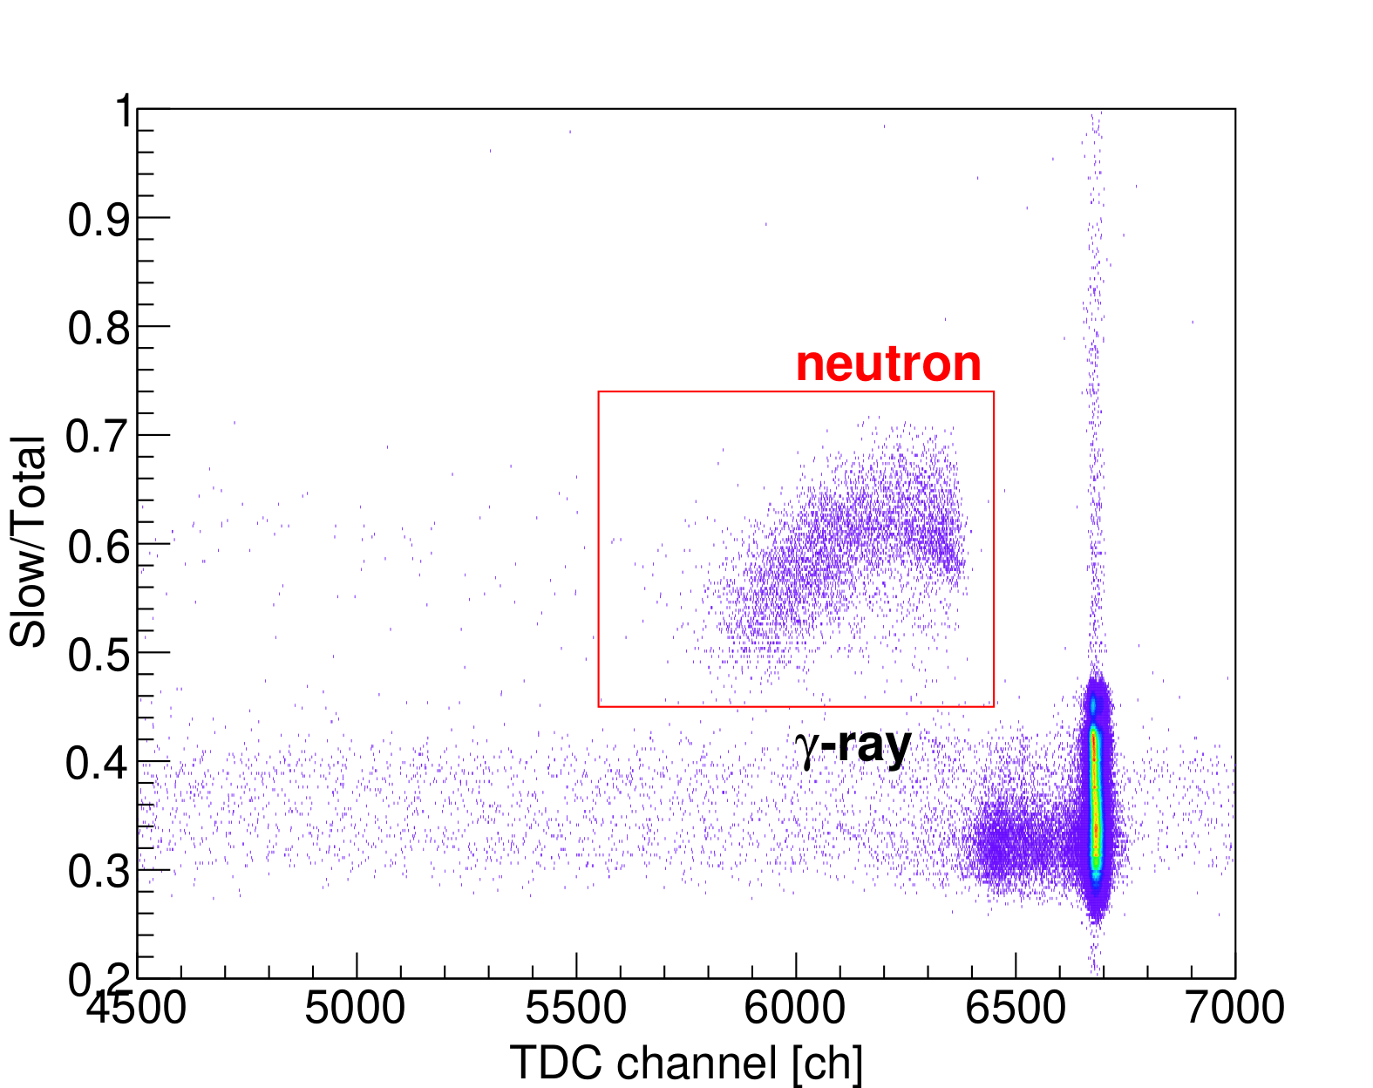
Figure 2. Separation of neutron and gamma events by using ratio of pulse heigh slow and total gates

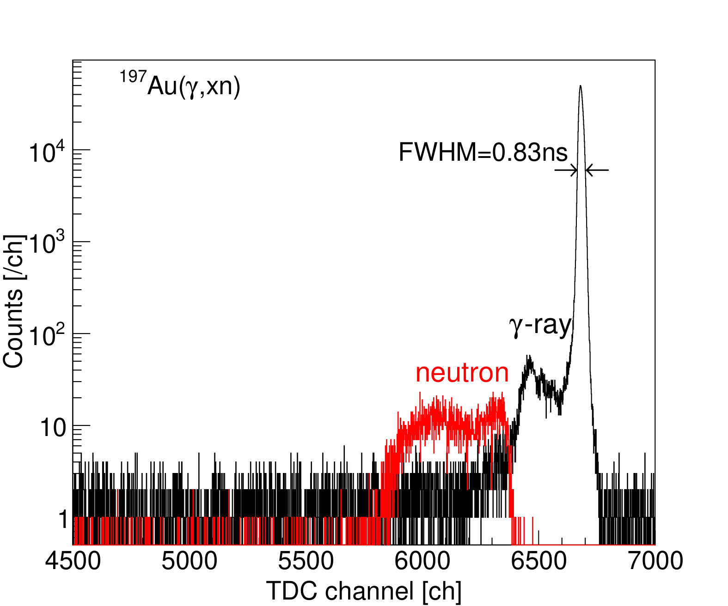
Figure 3. The neutron and gamma spectrum
We determined the efficiency of neutron detectors by measuring a ²⁵²Cf source and the SCINFUL-QMD simulation [7] to evaluate the total number of neutrons emitted from the target. The photon self-absorption factor inside the Au target was evaluated using the PHITS [8] simulation tool. With our setup, we obtained a time resolution of 0.83 ns at gamma peak and a neutron’s energy resolution of less than 10%.
The experimental data was obtained by using the polarized photon. In this work, we presented the DDXs, which were obtained by detectors at vertical 90 degrees and horizontal 60 degrees (H60) to minimize the polarization effect of the photon.

- Evaluated nuclear data library and PHITS calculation
In this work, the DDXs from the evaluated nuclear data library and PHITS calculation are compared with the experimental data. The DDXs were extracted from JENDL/PD-2004 and JENDL/PD-2016.1 library by our python-based software. The abundances of each target's isotopes were considered in calculating the DDXs from the JENDL/PD-2016.1 library. Because we experimented using the monoenergetic 16.6 MeV incident photons, the JENDL/PD-2016.1 DDXs of the incident photon’s energy within 16 MeV – 17 MeV were taken average to yield the spectrum of the library that should be compared to the experimental data.
We used PHITS to calculate the DDX of photoneutron produced by the 16.95 MeV photons incident on the Au, Pb, Sn, Cu, Fe, and Ti, which were natural targets. This energy was equal to the maximum energy used in the experiment. The targets were cylindrical in this simulation with both diameter and thickness of 5 µm to remove the self-absorption effect due to the target’s thickness. This self-absorption effect was considered in the experiment normalizing the DDX with the photon and neutron attenuation factors. The DDX was obtained on a detector cylinder, with both diameter and thickness of 12.7cm, placed at 90 degrees and 60 cm away from the target.

- Result and discussion
Figure 4 shows DDXs obtained from the experiment, the evaluated nuclear data libraries, the PHITS calculation for the Au target. The circles indicate the experimental data at horizontal 60o (H60), and the squares are the data at vertical 90o (V90). The experimental spectra indicate the low and high energy components.
The black and blue lines are PHITS results (version 3.16) and JENDL/PD-2004, respectively. The PHITS code has used the reaction cross-section from JENDL/PD-2004 and the Generalized Evaporation Model (GEM) to generate energy spectra. Different models predict the different DDXs, PHITS [9] has used the GEM, while JENDL/PD-2004 [10] has used exciton model-based code, CCONE, to produce the DDXs of photo-neutron. The both spectra are not consistent with the experimental spectra, the high-energy component was not reproduced by the PHITS and JENDL/PD-2004. In addition to this, the slope of the PHITS spectrum is lower than the experimental spectra.
The red line is the DDXs from JENDL/PD-2016.1. In this comparison, JENDL/PD-2016.1 produced the energy distribution in low energy, whereas this model cannot explain the high-energy component.
A maximum neutron energy was determined by subtracting Q_{value} of the (γ,xn) reaction from the photon energy. The maximum energy of results from the evaluated nuclear data and PHITS calculation are lower than the experimental data. The maximum energy in the JENDL and PHITS have been calculated using exactly the Q-value of the photonuclear reaction. In the photo-neutron measurement, that was impacted by energy resolution of neutron and the incident photon. The comparison of other targets is similar to that of Au.
In this comparison, PHITS simulation does not produce the high-energy component, in spite of the good agreement in the low-energy region below 4 MeV. Besides, the evaluated nuclear data library could not reproduce the high-energy region.
Figure 4. Results of PHITS, evaluated nuclear data libraries and experiment for the DDXs of ¹⁹⁷Au(γ,xn)

- Conclusion
We compared the double differential cross-section from the evaluated nuclear data library (JENDL/PD-2016.1) and the experiment. The results show disagreement between JENDL/PD-2016.1 and the experiment in high energy region. Thus, a model to reproduce the high energy component should be included in the simulation. To develop a model of high prediction power, further measurement on DDX is strongly desired for various targets and energies.
References
- T.K. Tuyet, Sanami T., Yamazaki H., et al. Energy and angular distribution of photo-neutrons for 16.6 MeV polarized photon on medium–heavy targets, Nucl. Instrum. Methods A 989 (2021) 164965.
- Kirihara Y., Nakashima H., Sanami T., et al. Neutron emission spectrum from gold excited with 16.6 MeV linearly polarized monoenergetic photons, J. Nucl. Sci. Technol. 57 (2020)
- Horikawa K., Miyamoto S., Mochizuki T., et al. Neutron angular distribution in (γ, n) reactions with linearly polarized γ -ray beam generated by laser Compton scattering. Phys. Lett. B 737 (2014).
- Agodi A. Nuovo Cimento, 5, 21, (1) (1957).
- Asano Y., Miyamoto S. Shielding design of laser electron photon beamlines at SPring-8. Prog Nucl Sci Tech. (2014).
- Miyamoto S., Asano Y., Amano S., et al. Laser Compton back-scattering gamma-ray beamline on NewSUBARU. Radiat Meas. (2007).
- Satoh D., Kunieda S., Iwamoto Y., et al. Development of SCINFUL-QMD code to calculate the neutron detection efficiencies for liquid organic scintillator up to 3 GeV. Nucl Sci Tech. (2002).
- Sato T., Iwamoto Y., Hashimoto S., et al. Features of Particle and Heavy Ion Transport code System, J. Nucl. Sci. Technol. (2018).
- Sato T., Niita K., Matsuda N., et al., Particle and Heavy Ion Transport Code System, PHITS, version 2.52, J. Nucl. Sci. Technol. 50 (2013) 913–923.
- Iwamoto N., Kosako K., Murata T., Photonuclear Data File JAEA-Conf 2016-004, pp. 53-58 (2016).

