Experimental plan for displacement damage cross sections using 120-GeV protons at Fermi National Accelerator Laboratory

Yosuke IWAMOTO^{1,2*}, Makoto YOSHIDA³, Shin-ichiro MEIGO², Katsuya YONEHARA⁴, Taku ISHIDA³, Keita NAKANO², Shin-ichiro ABE¹, Hiroki IWAMOTO^{1,2}, T. SPINA⁴, K. AMMIGAN⁴, N. MOKHOV⁴, Atsushi YABUUCHI⁵, and Toshimasa YOSHIIE⁵
¹Nuclear Science and Engineering Center, Japan Atomic Energy Agency
2-4 Shirakata, Tokai, Naka, Ibaraki 319-1195, Japan
²J-PARC Center, Japan Atomic Energy Agency
2-4 Shirakata, Tokai, Naka, Ibaraki 319-1195, Japan
³J-PARC Center, High Energy Accelerator Research Organization
1-1 Oho, Tsukuba, Ibaraki 305-0801, Japan
⁴Fermi National Accelerator Laboratory
Batavia IL 60510-5011, U.S.
⁵Institute for Integrated Radiation and Nuclear Science, Kyoto University
2, Asashiro-Nishi, Kumatori, Sennan, Osaka 590-0494, Japan
*Email: iwamoto.yosuke@jaea.go.jp

For the validation of the number of displacements per atom (dpa) calculated by Monte Carlo codes, an experimental program has been launched to measure displacement cross sections of metals with 120-GeV protons at Fermilab Test Beam Facility (FTBF) in Fermi National Accelerator Laboratory (FNAL). Experiments will be performed at the M03 beam line high-rate tracking area in FTBF in the US fiscal year 2022 (October 2021 – September 2022). For the preparation of experiments, the sample assembly with four-wire samples of aluminum, copper, niobium and tungsten with 250-μm diameter have been developed. The sample assembly will be maintained at around 4 K by using a Gifford–McMahon (GM) cryocooler in a vacuum chamber. Then, changes in the electrical resistivity of samples will be obtained under 120-GeV proton irradiation. To obtain a sufficient resistance increase under the beam irradiation, approximately 40 hours is needed for all samples. Recovery of the accumulated defects through isochronal annealing, which is related to the defect concentration in the sample, will also be measured after the cryogenic irradiation.

Introduction
To predict the operating lifetime of materials in high-energy radiation environment at accelerator facilities, Monte Carlo codes such as PHITS[1,2,3], MARS[4], and FLUKA[5] are used to calculate the number of displacements per atom (dpa) related to the number of Frenkel pairs. The Norgertt–Robinson–Torrens (NRT) model has been widely used to predict the number of the “initial” Frenkel pairs (NRT-dpa) [6]. For more accurate estimation of the actual damage production, athermal-recombination-corrected displacement damage (arc-dpa) was proposed [7]. For the validation of codes, it is necessary to measure displacement cross-sections of metals in relation to changes in electrical resistivity at cryogenic temperature (around 4 K) where the recombination of Frenkel pairs by thermal motion is well suppressed.
To validate the code, we developed the cryogenic irradiation chamber and measured displacement cross section of copper with 125 MeV protons [8], data of aluminum, copper and tungsten with 200 and 389 MeV protons [9,10], and data of copper and iron with 0.4 – 3 GeV protons [11], respectively. The comparison of displacement cross sections between the data and calculated results indicates that the arc-dpa results are in a good agreement with the data while the NRT-dpa results are larger than the data by about a factor of three. The measurement of aluminum, copper, iron and tungsten with 30-GeV protons will be performed at J-PARC. Since there is no experimental data with energy over 30 GeV, we have launched an experimental program to measure displacement cross sections of metals with 120-GeV protons at Fermilab Test Beam Facility (FTBF) in Fermi National Accelerator Laboratory (FNAL). In this paper, we introduce the experimental plan and the progress of the preparation.

Experimental plan and progress of the preparation

Experimental device
Experiments will be performed at the M03 beam line high-rate tracking area in FTBF in the US fiscal year 2022 (October 2021 – September 2022). The beam consists of 120 GeV protons. The length of spill is 4.2 seconds and approximate repetition is 60 seconds. Figure 1 shows the layout of the experimental area at M03 and picture of the irradiation chamber with the cold head of the Gifford-McMahon (GM) cooler (RDK-408D2, Sumitomo Heavy Industries, Ltd.) with 1.0 W cooling capacity at 4.2 K.
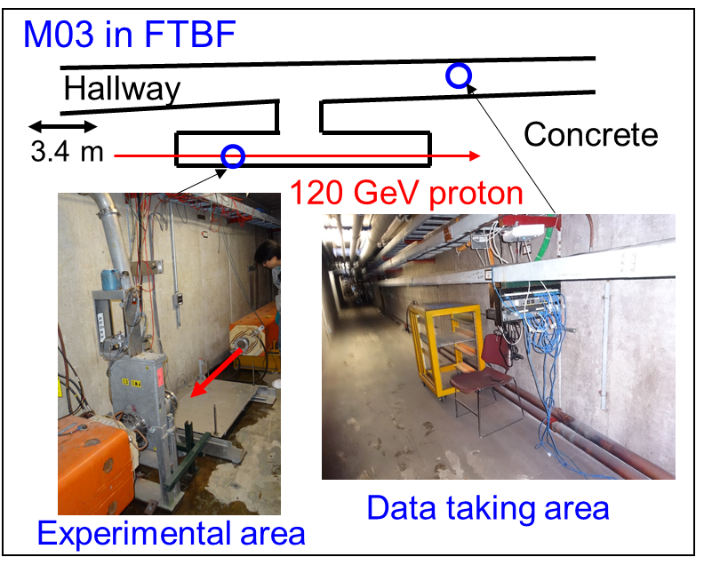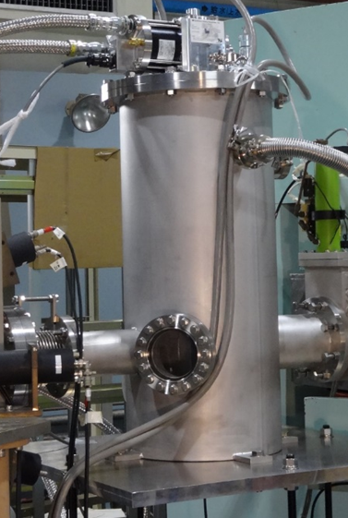
Figure 1: The experimental area at M03 (left) and an irradiation chamber with the GM cooler (right).

The irradiation chamber developed in our previous study [9,10] will be put on the beam line in the experimental area. A data taking system and the helium gas compressor for the operation of the GM cryocooler will be set at the data taking area. A segmented wire ionization chamber (SWIC) will be installed for the beam profile at front and back of the irradiation chamber. Beam scan is possible in horizontal and vertical directions with SWIC. An ion chamber operational in the upstream enclosure in the same beamline will be used for the beam current measurement. Figure 2 shows layout of the irradiation chamber drawn by PHITS.
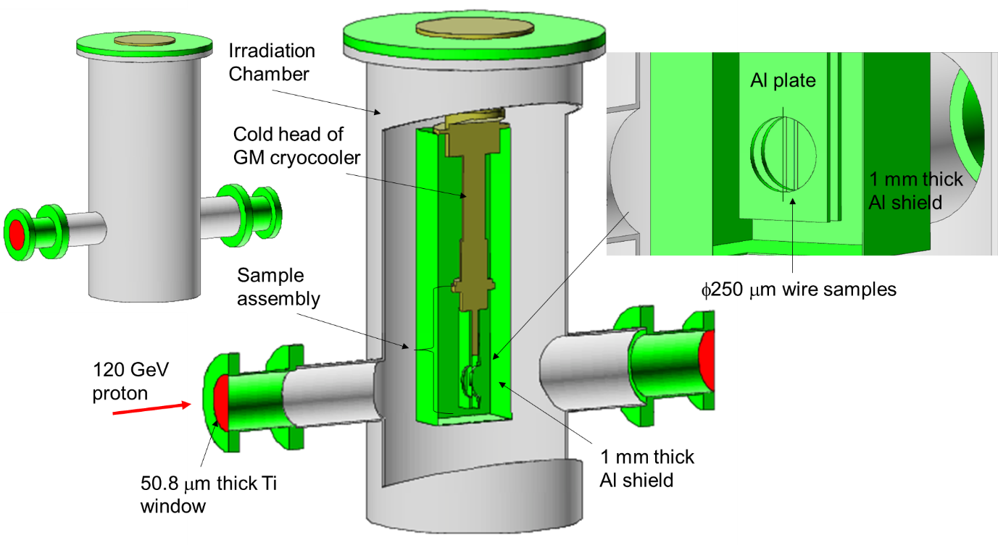
Figure 2: Layout of the irradiation chamber with the cold head of the GM cryocooler drawn by PHITS.

The sample assembly is connected with the cold head of the GM cryocooler and 1-mm-thick aluminum shields cover the entire sample assembly to intercept any thermal radiation from the irradiation chamber. Two 50.8 μm thick titanium windows will be connected with the irradiation chamber as a vacuum partition. Figure 3 shows the sample assembly connected with the cold head of the GM cryocooler in the irradiation chamber and the data taking system.

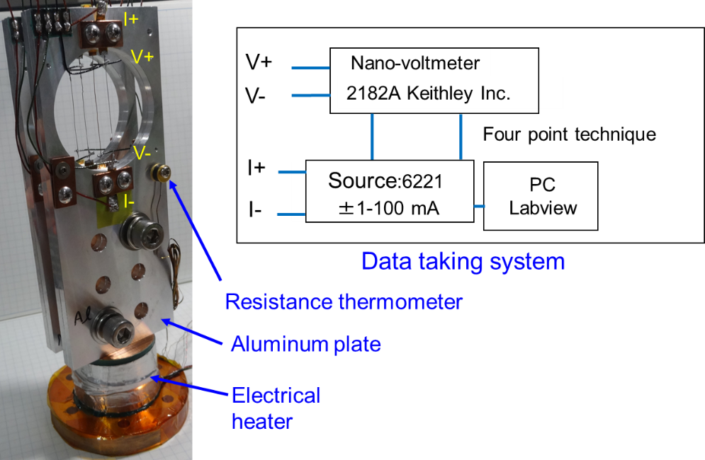
Figure 3: The sample assembly connected with the cold head of the GM cryocooler in the irradiation chamber (left) and the data taking system (right).

The aluminum plate is a support plate of a wire sample with a beam hole open to the beam. A root mean square (RMS) beam size can be 4 mm for protons. Since a 5-sigma of beam size or more is needed for the beam clearance in this experimental area at M03, the diameter of the beam hole was set to 48 mm (6-sigma). Since beam loss permits less than 3 % of the interaction length at M03, which is 12 mm for 120 GeV proton on aluminum, we cannot use aluminum nitride plates and the aluminum plates covering the sample wire in the beam line in the same way as our previous experiments at RCNP, Osaka university [9,10]. In the experiment at M03, four wire samples, aluminum, copper, niobium, and tungsten, with a 250-μm diameter were attached as shown in Figure 3 to minimize a beam loss. Before attaching an aluminum plate, wire samples were annealed with a vacuum electric furnace for aluminum and copper and an electron gun for niobium and tungsten. Table 1 lists the annealing temperature for these samples.

Table 1: Melting point, annealing temperature and annealing time for wire samples.
 | Melting point (K) | Annealing temperature (K) | Time (min.)
Al | 933.5 | 840 | 30
Cu | 1358 | 1289 | 30
Nb | 2750 | 1923 | 15
W | 3695 | 2473 | 15

Annealing under vacuum conditions (~10⁻⁴ Pa) was performed by heating the samples to the temperatures shown in Table 1.
The electrical resistance of wire will be measured using an apparatus combining a current source (model 6221, Keithley Instruments Inc.) and a nano-voltmeter (model 2182A, Keithley Instrument Inc.). This apparatus is based on four-point technique with cancel effects of thermal electromotive force. The precision of the electrical resistance at 3 K was 0.001 μΩ. A CX1050-CU-HT Cernox resistance thermometer was attached in the aluminum plate near samples. A 48 Ω electrical heater was attached to the copper block for the study of the recovery of accumulated defects through isochronal annealing after the cryogenic beam irradiation. The measurement procedure of recovery of defect is as follows: the sample is warmed to the annealing temperature with a heater, and sample temperature holds with constant for about 10 minutes. After the sample is cooled to 4 K by the GM cryocooler, electrical resistivity of the sample is measured [8-11].

Estimation of required beam time and heat load
The required beam time for this experiment was estimated from arc-dpa displacement cross sections calculated by PHITS. The displacement cross section σ can be related to the resistivity increase and the beam fluence:
$σ=\frac{1}{ρ_{FP}}\frac{∆ρ_{sample}}{ϕ}$ (1)
$∆ρ_{sample}=\frac{A}{L}∆R_{sample}$ (2)
where ρ_{FP} is the Frenkel pair resistivity of sample, φ is the beam fluence, $∆ρ_{sample}$ is the electrical resistivity change of sample and $∆R_{sample}$ is the electrical resistance change under the beam irradiation. Table 2 lists the estimation of the required beam fluence for samples.

Table 2: Estimation of required beam fluence.
 | Al | Cu | Nb | W
Calculated arc-dpa displacement cross section σ (m²) | 2.36 × 10⁻²⁶ | 9.44 × 10⁻²⁶ | 1.66 × 10⁻²⁵ | 2.9 × 10⁻²⁵
Frenkel pair resistivity ρ_{FP} (μΩm) | 3.7 | 2.2 | 14 | 27
Length of two potential points (mm) | 40 | 37.5 | 38.5 | 37.5
Geometry factor (A/L) (m) | 4.91 × 10⁻⁶ | 5.24 × 10⁻⁶ | 5.10 × 10⁻⁶ | 5.24 × 10⁻⁶
Resistance increase $∆R_{sample}$ (μΩ) | 0.4 | 1.0 | 10 | 35
Beam fluence φ (1/m²) | 2.25 × 10¹⁹ | 2.52 × 10¹⁹ | 2.19 × 10¹⁹ | 2.34 × 10¹⁹

In Table 2, the arc-dpa displacement cross section σ was calculated by PHITS, ρ_{FP} was obtained from Ref. [12], and the geometry factor was obtained by the ratio of the area (A) of the cross section of the wire to the length of two potential points (L) of the wire. φ was estimated with $∆R_{sample}$, which is a measurable value. On the other hands, the proton beam intensity is around 5 × 10¹¹ (protons/minute) and estimated beam area is about 5 × 10⁻⁵ (m²) at M03. In this beam condition, the beam fluence on the wire sample is 1.2 × 10¹⁹ (protons/m²) for 20 hours irradiation, 2.4 × 10¹⁹ (protons/m²) for 40 hour irradiation, and 3.6 × 10¹⁹ (protons/m²) for 60 hours irradiation, respectively. To obtain the resistance increase listed in Table 2, approximately 40 hour irradiation is needed.
Since the cold head of the GM cooler has 1.0 W cooling capacity at 4.2 K, we estimated the heat load of beam in the cold head and sample wires using PHITS. The heat load in the cold head was regarded as a sum of the energy deposition in the cold head, the sample assembly including wire samples and the 1 mm thick aluminum shields as shown in Figure 2. Table 3 lists the heat loads in the wire samples and the cold head calculated by PHITS.

Table 3: Heat load in wire samples and cold head calculated by PHITS.
 | Heat load
 | J/proton | J/shot
Wire samples | 4.81 × 10⁻¹⁴ | 2.41 × 10⁻²
Cold head | 5.68 × 10⁻¹³ | 2.84 × 10⁻¹

The beam intensity was estimated to be 5 × 10¹¹ (protons/shot). Since the results are lower than 1 W, the cooling power of the cold head is enough to cool samples during the beam irradiation.

Summary
The paper describes the plan to measure displacement cross sections of aluminum, copper, niobium and tungsten with 120-GeV protons at FTBF in FNAL. Experiments will be performed at the M03 beam line high-rate tracking area. For preparation of experiments, we developed the sample assembly with four wire sample with 250-μm diameter. The sample assembly will be maintained at around 4 K by using the GM cryocooler in a vacuum chamber. Then, changes in the electrical resistivity of samples will be obtained under 120-GeV proton irradiation. To obtain the sufficient resistance increase under the beam irradiation, approximately 40 hours is needed for all samples. The cooling power of the cold head is enough to cool samples during the beam irradiation. Recovery of the accumulated defects through isochronal annealing will also be measured after cryogenic irradiation.

References
- Sato, T. et al., Features of Particle and Heavy Ion Transport code System (PHITS) version 3.02, J. Nucl. Sci. Technol., vol.55, 2018, pp.684-690.
- Iwamoto, Y. et al., Calculation of displacement cross-sections for structural materials in accelerators using PHITS event generator and its applications to radiation damage, J. Nucl. Sci. Technol., vol.51, 2013, pp.98-107.
- Iwamoto, Y. et al., Estimation of reliable displacements-per-atom based on athermal-recombination-corrected model in radiation environments at nuclear fission, fusion, and accelerator facilities, J. Nucl. Mater., vol.538, 2020, 152261.
- Mokhov, N.V. and James, C.C., The MARS code system user’s guide, version 15 (2016), Fermilab-FN-1058-APC, 2017; https://mars.fnal.gov
- Böhlen. T.T. et al., The FLUKA code: developments and challenges for high energy and medical applications, Nucl. Data Sheets, vol.120, 2014, pp.211-214.
- Norgett, M.J. et al., A proposed method of calculating displacement dose rates, Nucl. Eng. Des., vol.33, 1975, pp. 50-54.
- Nordlund, K. et al., Primary radiation damage: a review of current understanding and models, J. Nucl. Mater., vol.512, 2018, pp. 450-479.
- Iwamoto, Y. et al., Measurement of the displacement cross-section of copper irradiated with 125 MeV protons at 12 K, J. Nucl. Mater., vol.458, 2015, pp. 369-375.
- Iwamoto, Y. et al., Measurement of displacement cross sections of aluminum and copper at 5 K by using 200 MeV protons, J. Nucl. Mater., vol.508, 2018, pp. 195-202.
- Iwamoto, Y. et al., Measurements of displacement cross section of tungsten under 389-MeV proton irradiation and thermal damage recovery, Materials Science Forum, vol.1024, 2021, pp. 95-101.
- Matsuda, H. et al., Measurement of displacement cross-sections of copper and iron for proton with kinetic energies in the range 0.4 – 3 GeV, J. Nucl. Sci. Technol., vol.57, 2020, pp.1141-1151.
- Broeders, C.H.M, and Konobeyev, A.Yu., Defect production efficiency in metals under neutron irradiation, J. Nucl. Mater., vol.328, 2004, pp. 197-214.

Acknowledgements
The authors wish to express their gratitude to Dr. Adam C. Watts and the staff at FNAL for their generous support. This work is supported by JSPS KAKENHI Grant Number JP19H02652 and performed under the Radiation Damage In Accelerator Target Environments (RaDIATE) international collaboration.

