* ADC to energy mapping

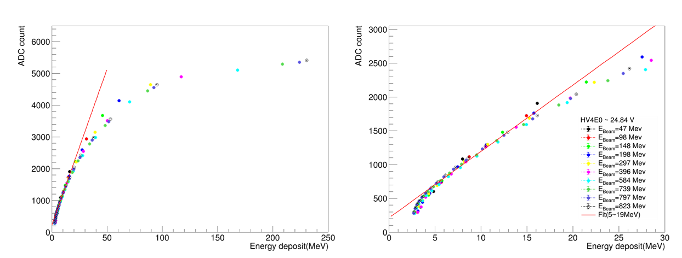

Fig. 1 presents the ADC to energy deposition mapping for the 1st ZDC ECal prototype. The left panel shows the full energy range, while the right panel zooms in on the linear range. A red line indicates the linear fit applied in the energy range of 5 MeV to 20 MeV, which is considered the linear response range of the system.

Fig. 1 illustrates the ADC to energy deposition mapping for the 1st ZDC ECal prototype, incorporating all beam energies tested. Several observations stand out:

1. The beam energies align well across the plot.
2. A strong saturation effect is seen in the SiPM when energy deposition exceeds 30 MeV.
3. At lower energies (Edep < 5 MeV), there is a noticeable non-linear effect, though the cause is uncertain.

Due to the pronounced saturation, most of the data fall within the saturated range, except for the 47 MeV data. Approximately 60% of the data from the 47 MeV electron beam remain in the linear range, and we will focus on these data first.

* Cut criteria

Two cut criteria were applied to the 47 MeV data for analysis:

1) To focus on the data from the linear range, the energy of the most energetic tower was restricted to 2.5 MeV to 20 MeV.

2) Since the beam is expected to hit the center of the calorimeter, the shower should impact both the left and right pixels. We required that at least one pixel fired on both the left and one pixel fired on the right.

Fig. 2 shows the distribution of the most energetic pixel at 47 MeV. Before applying the cuts, a low-energy peak was observed, which may be caused by low-energy photons accompanying the beam according to documentation from ELHF [cite ELHF document]. Since our system is self-triggered, we could not filter out these events during data collection and could only remove them in the off-line analysis.

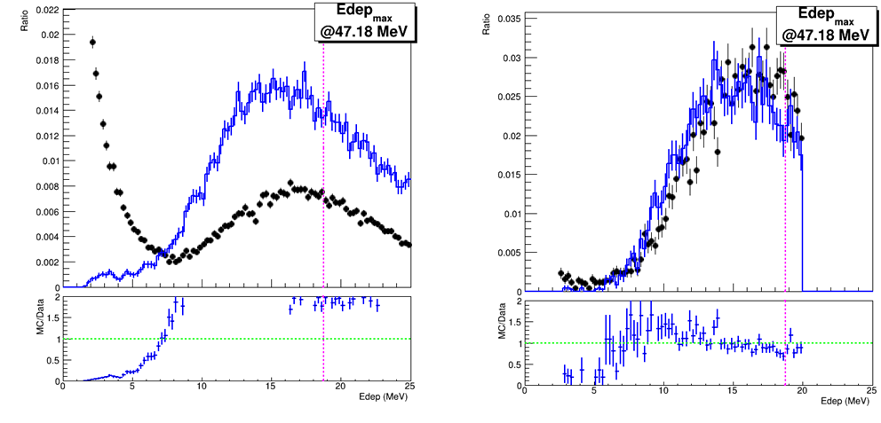

Fig.2 The energy distribution of the most energetic pixel at 47MeV. (Left) Before the cuts, (Right) After the cuts. (Top) Data and MC comparison. (Bottom) Ratio of MC divided by Data

* Energy deposition on crystal

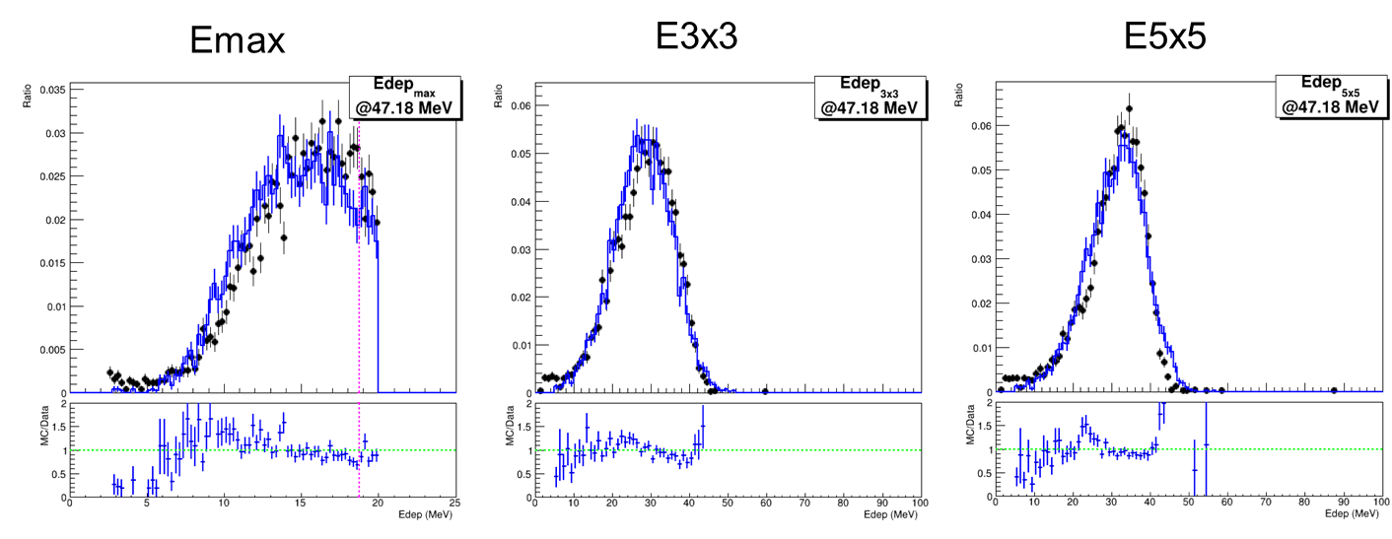

Fig. 3 displays the energy sum of pixels with the 47 MeV electron beam: (Top row) Data and MC comparison, (Bottom row) The ratio of MC to data; (Left) Most energetic pixel. (Middle) Energy sum of a 3x3 grid of crystals centered on the most energetic pixel, (Right) The energy sum of a 5x5 grid of crystals centered on the most energetic pixel.

Fig. 3 shows the energy of pixels with 47MeV electron beam. The agreement between data and MC are reasonable, even though the sum energy of data is slightly larger than MC.

* Energy resolution (rough estimation)

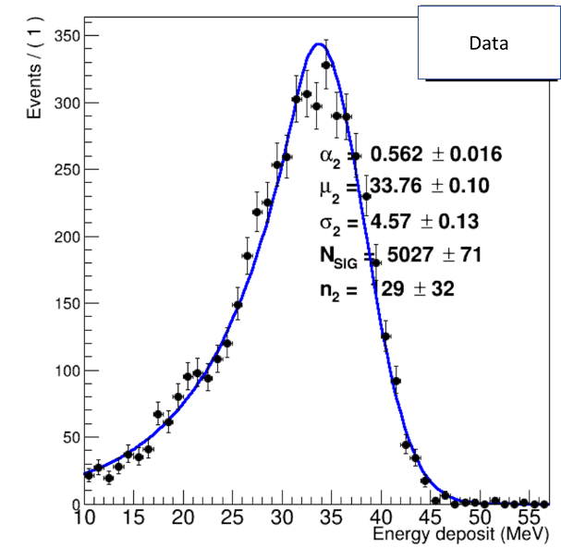

Fig. 4 : Crystal ball fitting of energy sum of 5x5 crystals for 47MeV data.

Since energy regression has not yet been finalized, we are unable to provide an exact energy resolution for the system. However, a rough estimate is possible. As shown in Fig. 4, a crystal ball fit of the energy sum from the 5x5 crystals using data from 47 MeV electron beam results. For data, it is in a mean value of 33.76 ± 0.1 MeV and a sigma of 4.57 ± 0.13 MeV. Based on these values, the worst-case energy resolution is estimated to be better than 13% for the 47 MeV electron beam.